Title
Ways forward for aquatic conservation: applications of environmental psychology to support management objectives.

Author names and affiliations.
Kate Walker-Springett (corresponding author)^{a,I}
Rebecca Jefferson^{b, c}
Kerstin Böck^{d}
Annette Breckwoldt^{e}
Emeline Comby^{f}
Marylise Cottet^{g}
Gundula Hübner ^{h}
Yves-François Le Lay^{i}
Sylvie Shaw^{j}
Kayleigh Wyles^{k}

ªUnderstanding Risk Research Group, Cardiff University, Park Place, Cardiff, CF10 3AT, UK
^{I}Present Address: Exeter University, College of Life and Environmental Science, Geography Department, Amoury Building, Rennes Drive, Exeter, EX4 4RJ, UK. Email: k.walker-springett@exeter.ac.uk. Phone: 0044 (0)7729218160
^{b}RSPB Centre for Conservation Science, RSPB, The Lodge, Sandy, Bedfordshire, SG19 2DL, UK. rebecca.jefferson@rspb.org.uk
^{c}Centre for Marine and Coastal Policy Research, Plymouth University, Drake Circus, Plymouth PL4 8AA, UK
^{d}Institute of Hydrobiology and Aquatic Ecosystem Management, University of Natural Resources and Life Sciences, Vienna, Austria, kerstin.boeck@boku.ac.at
^{e}Leibniz-Center for Tropical Marine Ecology (ZMT), Bremen, annette.breckwoldt@zmt-bremen.de
^{f} University of Lyon, CNR UMR 5600 Environnement, Ville, Société, ENS de Lyon, 15 Parvis René Descartes, BP 7000, 69342 Lyon CEDEX 07, emeline.comby@ens-lyon.fr
^{g} University of Lyon ,CNRS UMR 5600 Environnement, Ville, Société, ENS de Lyon, 15 Parvis René Descartes, BP 7000, 69342 Lyon CEDEX 07, marylise.cottet@ens-lyon.fr
^{h}Institute of Psychology, Martin-Luther-University Halle-Wittenberg, 06099 Halle; MSH Medical School Hamburg, Germany, gundula.huebner@psych.uni-halle.de
^{i}University of Lyon, CNR UMR 5600 Environnement, Ville, Société, ENS de Lyon, 15 Parvis René Descartes, BP 7000, 69342 Lyon CEDEX 07, yves-francois.le-lay@ens-lyon.fr
^{j}School of HIstorical and Philosophical Inquiry, The University of Queensland, St Lucia, 4067, Queensland, Australia, sylvie.shaw@uq.edu.au

^{k}School of Psychology, Plymouth University, Drake Circus, Plymouth, Devon, PL4 8AA; Present address: Plymouth Marine Laboratory, Prospect Place, The Hoe, Plymouth, Devon, PL1 3DH, UK, kaw@pml.ac.uk

Abstract
The success or failure of environmental management goals can be partially attributed to the support for such goals from the public. Despite this, environmental management is still dominated by a natural science approach with little input from disciplines that are concerned with the relationship between humans and the natural environment such as environmental psychology. Within the marine and freshwater environments, this is particularly concerning given the cultural and aesthetic significance of these environments to the public, coupled with the services delivered by freshwater and marine ecosystems, and the vulnerability of aquatic ecosystems to human-driven environmental perturbations. This paper documents nine case studies which use environmental psychology methods to support a range of aquatic management goals. Examples include understanding the drivers of public attitudes towards ecologically important but uncharismatic river species, impacts of marine litter on human well-being, efficacy of small-scale governance of tropical marine fisheries and the role of media in shaping attitudes towards. These case studies illustrate how environmental psychology and natural sciences can be used together to apply an interdisciplinary approach to the management of aquatic environments. Such an approach that actively takes into account the range of issues surrounding aquatic environment management is more likely to result in successful outcomes, from both human and environmental perspectives. Furthermore, the results illustrate that better understanding the societal importance of aquatic ecosystems can reduce conflict between social needs and ecological objectives, and help improve the governance of aquatic ecosystems. Thus, this paper concludes that an effective relationship between academics and practitioners requires fully utilising the skills, knowledge and experience from both sectors.

Keywords
Conservation; marine; freshwater; environmental management; human well-being; environmental values

- Introduction
The natural sciences record the ecological consequences of human exploitation of aquatic ecosystems both freshwater (e.g. rivers and lakes) and marine (e.g. beaches and seas) (Halpern et al., 2008; Malmqvist & Rundle, 2002). This science informs environmental managers of the effects of resource overuse, such as biodiversity loss (Strayer & Dudgeon, 2010; Worm et al., 2006), degradation of habitat (Dudgeon et al., 2006; Polidoro et al., 2010;) and other anthropogenic driven changes to ecosystems (Harley et al., 2006; Ormerod, Dobson, Hildrew, & Townsend, 2010). In parallel to these large-scale environmental impacts, humans receive many benefits from freshwater and marine ecosystems such as food, shelter, renewable energy production, cultural significance and wider well-being benefits (UNEP, 2006; White, Alcock, Wheeler, & Depledge, 2013) illustrating the complex relationship between humans and aquatic systems, with both positive and negative components. Looking to the future, this human-environment relationship must be revised into a sustainable approach to aquatic environment management if marine and freshwater conservation management goals are to be achieved and the current overuse of aquatic ecosystems reduced.
Recognising both the scale of the management challenges in aquatic ecosystems and the considerable social component of the required response, there have been increasing calls to incorporate social science approaches into management efforts (e.g. Fletcher, Jefferson, & McKinley, 2012; Sandbrook, Adams, Buscher, & Vira, 2013; Schultz, 2011). To deliver sustainable use of aquatic resources and reduce the degradation of ecosystem health, environmental managers face numerous challenges to engage society and deliver their management objectives. Challenges include: engaging stakeholders in management processes (Leslie & McLeod, 2007), engaging large and public audiences (Vincent, 2011), balancing differing values of aquatic resources (Klein et al., 2008) and understanding the connections between society and aquatic environments (McKinley & Fletcher, 2012). Within the social sciences, environmental psychology investigates the interactions and connections between people and their environment, interrogating the values and motivations behind particular attitudes and behaviours (Bechtel & Churchman 2002; Gifford, 2007; Saunders, 2003). Environmental psychology provides a rich array of methods to support environmental managers in addressing the societal challenges they face. There are, however, barriers to integrating any social science approach into natural environmental science research and practice. For example, Fox et al. (2006) describe the lack of a shared vocabulary, interdisciplinary funding and collaboration opportunities. Environmental psychology brings with it methods, theories, jargon and philosophies which are unfamiliar in many traditional conservation spheres. These can prevent the application of environmental psychology approaches despite the potential benefits of persisting against these barriers. Recent action such as the World Social Science Report on Changing Global Environments (ISSC & UNESCO, 2013) are proactively addressing these challenges and recommending advances to increase interdisciplinary working which blends natural and social sciences.
The integration of environmental psychology and natural science has already received some successes. The concept of Community Based Conservation (CBD) is based on the premise that long-term conservation success needs to include humans in the wider definition of ecosystems; explicitly including the development needs and expectations of the local community is believed to increase conservation success (Berkes, 2004). Critical analysis of CBD projects reveals that CBD approaches need to be specifically attuned to the needs of each individual community and the wider national perspective within which the conservation project exists (Brooks, Waylen, & Mulder, 2013). This clearly indicates that an in-depth understanding of the attitudes and policy drivers at both the local and national scale is vital. More specific examples of work to include values and attitudes in environmental management show how management choices and ecosystem assessments can be made more effective and accurate with use of local knowledge and by adapting management choices to better fit with local values (for examples see Fischer & van der Waal (2007) in Scotland, and Moller, Berkes, Lyver, & Kislalioglu (2004) in Canada and New Zealand).

In this paper, we use case studies to illustrate the benefits that can be achieved through applying environmental psychology approaches to aquatic management. The field of environmental psychology, defined as the study of how humans affect and are affected by the environment, seeks to identify and empirically test strategies to promote a more sustainable use of the natural environment, irrespective of the founding discipline (De Young, 2013). The methods and approaches detailed within this paper may resonate with readers from other disciplines, such as human geography or landscape planning, due to the interdisciplinary backgrounds of our authors. The paper illustrates how environmental psychology approaches can play a role in aquatic management research and contribute to achieving management goals. This paper also evaluates the cases studies and provides recommendations for furthering the natural science – environmental psychology relationship.
- Methods and Results
The geographical scope and spatial scales of the case studies highlight the diverse range of interactions between humans and aquatic environments. Case studies 2.1 to 2.4 are concerned with freshwater environments whilst case studies 2.6 to 2.9 focus on the marine environment. Case study 2.5 provides the transition from freshwater to marine through a catchment-based perspective. The case studies are then ordered from large-scale approaches through to more small scale, site-specific examples. It is useful to investigate a range of spatial scales given the variety of scale relevant in aquatic management. Furthermore, researchers from a variety of disciplines have conducted the case studies; some are written from the perspective of a psychologist looking towards the ecological and natural perspectives, whilst others are written by ecologists applying psychological methods.
Each case study briefly documents the context and methods of the study before discussing the findings. These nine case studies are overviews of larger research studies and further details can be found in the cited References and Acknowledgements section.

  - Human-Nature Relationship Perspectives in River Landscape Management
Understanding the relationship humans have with nature plays an important role in environmental management (Bauer, Wallner, & Hunziker, 2009). It is particularly relevant with regard to the on-going paradigm shift in river management that follows more sustainable and participatory approaches. In this context it can help to investigate the range of different underlying relationships people have with their local river and how these relate to their visions of river use and management (de Groot & de Groot, 2009) to encourage and support mutual understanding between different user groups. In order to investigate these relationships within the context of river landscape management, a list of six typologies of human-nature relationships were developed, based on a literature review (Flint, Kunze, Muhar, Yoshida, & Penker, 2013) and explorative interviews. For each typology of human-nature relationships, narratives were written to exemplify how these types were characterized (Table 1).
Typology | Description
Master | I think humans can become independent from nature, by developing technology, and should control and change nature. The production of necessary goods, for instance food, can be improved and natural hazards like floods can be averted.
Apathy | I do not think about nature much in my daily life
User | I believe humans benefit from functioning ecosystems, for instance from clean water, timber or the beauty of landscapes. Hence functioning ecosystems can also create jobs and profits.
Steward | I see a moral obligation to conserve and protect nature, because human development and technology can be a threat to nature.
Partner | I consider humans and nature as equal in value and power. Nature has a value in itself, which cannot be only be measured according to human utilisation.
Participant | I feel as part of nature. I have an emotional or spiritual bond with it. Being or living in nature is fulfilling for me. Our existence and the well-being of nature are intertwined. We cannot separate humans from nature.
Table 1: Typologies of human-nature relationships, used to explain stakeholder relationships towards river management practices. The description illustrates the underlying characteristics explained by each typology.
These narratives were applied in quantitative questionaire (n=505) and qualitative interviews (n=25) to assess human-nature relationship perspectives and their possible applicability to support participatory management processes in two Alpine river landscapes in Austria (Fig. 2.1).
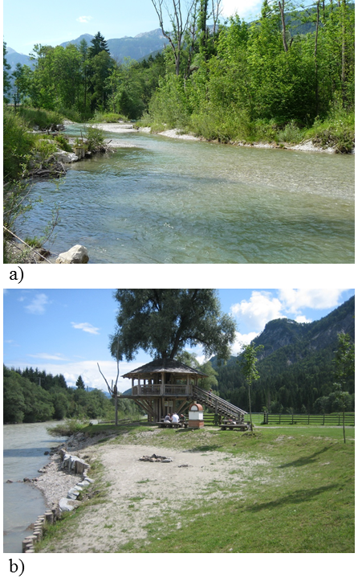
Figure 2.1: Case study areas: a) River landscape Enns, Austria, b) River landscape Drau, Austria.
Perspectives of different stakeholders with backgrounds from the fields of water management, recreational fisheries, nature protection and politics were assessed. The participants had either a recreational or professional relationship to the case study area.
Few participants directly aligned themselves with the master typology (52.4% and 72.2% of participants disagreed with this typology at the River Drau and River Enns respectively). Instead, many interviewees perceived themselves as being users, stewards or participants of nature. This result is comparable to findings of de Groot, & de Groot (2009) where river residents “fiercely rejected” the image of “mastery over nature”. However, during qualitative interviews, interviewees referred to aspects of the master typology indirectly when describing their relationship to nature and realised that they often hold multiple and even conflicting human-nature relationship perspectives. For example, some interviewees perceived themselves as participant in their private life and at the same time behaving as master in their professional life.
Many participants showed a strong interest in thinking about their human-nature relationships in the context of decisions they made in their private or professional life. Applying the human-nature typology was seen as helpful with regards to the development of a common understanding between different user groups. Further research is needed to develop tools that can more fully explain the range of human nature relationships, which could be used to support participatory processes and the implementation of agreed management objectives.

  - What is river quality? Incorporating the perspectives of lay‐people in river restoration

Braided rivers are characterised by numerous, mobile channels that split and reconnect around river bars and alluvial islands (Lane, 1957). Braided rivers create a diverse mosaic of dynamic and connected subterranean and aquatic habitats, which support high levels of biodiversity. As a result of anthropogenic activities, the Magra River in northern Italy has become less braided, and consequently less ecologically diverse (Le Lay, Piegay, & Riviere-Honegger, 2013). In order to counter these alterations and meet the EU Water Framework Directive objectives of good ecological river status, a restoration project for the Magra River was implemented. However, ‘good’ river quality is subjective; environmental perceptions are known to partly depend on people’s knowledge and use of the area (House & Sangster, 1991; Mosley, 1989). Moreover, the success of river restoration projects is particularly dependent upon effectively considering the range of stakeholder and public perspectives on the project’s objectives (Raymond et al., 2010).

To assess public and stakeholder perceptions of the proposed works on the Magra River, a quantitative photo-questionnaire was developed depicting ten riverscapes with different proportions of water, vegetation and sediments (Fig. 2.2a). Participants were asked to score each photograph, from 1 (low) to 10 (high) in terms of aesthetic value, beneficial uses, and river management needs. Surveys were conducted with 127 people, belonging to five distinct groups: (1) 13-14 year old children attending school more than 10 km from the river, (2) 13-14 year old children attending school less than 1 km from the river, (3) scientists with scientific knowledge of river ecosystem function, (4) local river managers working for the government’s watershed authority and (5) residents within the Magra River catchment who use the river for recreational purposes.
The results showed a difference between the responses given by expert groups (scientists and managers) and non-expert groups (children and local residents): the physical characteristics of a braided river (for example the presence of gravel bars) were valued by scientists but were perceived as less valuable by the public. The results indicate that the public had a negative perception of landscapes that included a high proportion of gravel bars (Fig. 2.2b). The survey also demonstrated that local children had a more positive attitude towards braided rivers than children living further away from the river. Consequently, projects aiming to restore braided rivers, which aim to increase to the proportion of gravel bars, may meet a lack of understanding from adult local residents, but engagement with local schools could help the positive associations with braided rivers continue into adulthood.

The results of this study highlight the importance of implementing appropriate engagement activities when planning an environmental management project. Respondent familiarity and knowledge appear to be critical factors in determining perceptions of riverscapes (Le Lay, Cottet, Piégay, & Rivière-Honegger, 2012), and therefore must be considered when promoting ecological restoration projects (Cottet, Piegay, & Bornette, 2013).

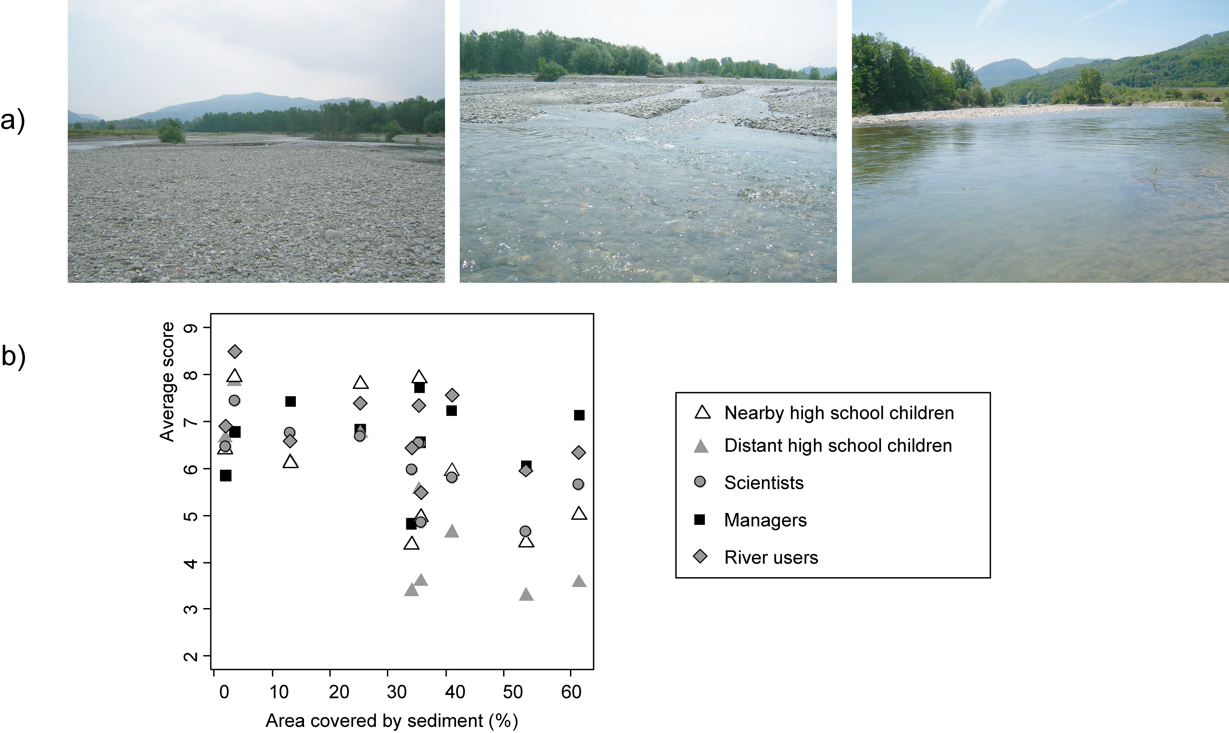
Figure 2.2: Public and stakeholder perceptions of Magra River (Italy): a) three of the ten photographs included in the photo-questionnaire; b) aesthetic values given by five respondent groups to ten photographs.

  - Conserving the ugly: The drivers behind the public’s perception of uncharismatic species
Charismatic species have long been used to spearhead conservation campaigns because of the emotional response they provoke (Lorimer, 2007). However, the species of greatest ecological priority may be unappealing to a lay-audience, particularly invertebrates (Munoz, 2007). Efforts to engage the public with conservation work often focus on providing information in an attempt to promote environmentally conscious behaviour. However, this knowledge deficit approach is an oversimplification as multiple factors, including a person’s values of the environment or species in question, also contribute towards environmental attitudes and behavioural intentions (Kollmuss & Agyeman, 2002). This case study examines a particularly unfamiliar invertebrate: the freshwater pearl mussel (Margaritifera margaritifera) (FPM), an endangered British mollusc found in upland rivers. By identifying if knowledge or values (or both) are most important in determining lay-person perceptions to this uncharismatic species, it is hoped that conservation efforts can become more targeted.
A nationally representative quantitative online survey was administered to participants in Wales and Scotland to investigate public knowledge and attitudes towards the FPM (n= 548). Questions were designed to reveal levels of respondent’s species knowledge, perceptions of the importance of conserving specific species and how rivers are valued. Results empirically showed that both values and knowledge play a role in determining the conservation importance attributed to the FPM. Analysis using a stepwise multiple regression model found that significant knowledge variables were the familiarity of the species and whether or not the species was considered native to the UK. Only one values measure, the value associated with local rivers, increased the model’s predictive capability (Walker-Springett, 2014).
That the only values measure to affect perceptions of FPM importance was the value of local rivers indicates that conservation agencies should adopt approaches that highlight the local benefits of rivers, in terms of ecology, resources (e.g. potable water) and recreational use. Such an approach is particularly important in view of the risk that negative connotations of climate change and flooding (Spence, Poortinga, Butler, & Pidgeon, 2011) might overshadow positive feelings generally associated with rivers (Kaplan, 1977). The knowledge factors showed that uncharismatic species such as the FPM may not be recognised because they are unfamiliar; their contribution to healthy and productive rivers habitats is not obvious to the lay person. It is recommended that local knowledge of this species should be enhanced, both through information and hands-on experience. Such an approach has already been successful on the River Clun, Shropshire, where local farmers themselves now act as advocates for the conservation of the FPM (M. Kelly, personal communication, May 30, 2011). It is expected that similar approaches could be conducted for other uncharismatic species.

  - How Pollution Became a Social Problem: Newspapers and Public Perceptions of PCB Pollutions in the Rhône River (France)
The long standing environmental issue of Polychlorinated Biphenyl (PCB) pollution in the Rhône River, France provides an opportunity to better understand attitudes towards riverine pollution events, and how to engage the public with such environmental issues. PCB pollution in the Rhône River was first recorded in the 1980s (Monod, Devaux, & Riviere, 1988) but by the 1990s, the issue of PCB pollution had been lost from public consciousness (Comby, Le Lay, & Piegay, 2014). In 2005, PCB pollution re-emerged as an issue in the Rhône River, being presented in the media as a disaster caused by riverine industrialisation. Five years later, the continued pollution of the Rhône River was no longer receiving large media coverage. This study highlights the potential for newspapers to be used as data sources to analyse the evolution of public attitudes towards a somewhat invisible environmental issue.
A qualitative methodology was derived from geography, environmental sociology, and environmental psychology disciplines, and used media content analysis, ethnographic interviews and participant observation (n = 10). A media analysis was conducted on coverage of the PCB pollution of the Rhône River by three regional newspapers between 2005 and 2010 (Fig. 2.3) because “environmental messages delivered via print media and Internet are more likely to spur people's interest” (Jiménez-Castillo & Ortega-Egea, 2015). During this time, we compared Le Progrès, covering the upstream stretch of the Rhône River, Le Dauphiné Libéré, covering the middle valley area, and La Provence, covering the downstream stretch. The timeline of articles related to the PCB pollutions shows that the first article was published on the 15th September 2005 in Le Progrès; no other newspapers covered this story between 2005 and 2007. Le Dauphiné Libéré published their first story regarding the pollution on the 4th March 2007, and La Provence on the 21st April 2007. Levels of public awareness of this environmental problem were seen to increase until 2008, which corresponds with the subsequent decrease in media coverage after 2008. Elevated levels of public awareness were also linked to actions by individuals and organisations promoted through the media. The changing patterns of media coverage of PCB pollution also appears to influence the waning and waxing of attention given to this issue by policy makers, seen in the frequency and promotion of legal acts created to address the issue (Comby et al., 2014).
This research illustrates the value of newspapers as a tool to retrospectively evaluate the emergence of public attitudes about environmental issues, and also raises important questions regarding the consequences of delays in media coverage about environmental issues on policy makers and public attitudes, which are both reflected and shaped by newspapers. Furthermore, the study indicates that river managers could use the media as a tool to encourage concern about pollution events, but further work would be needed to assess the duration of public concern, after the media coverage has ended.
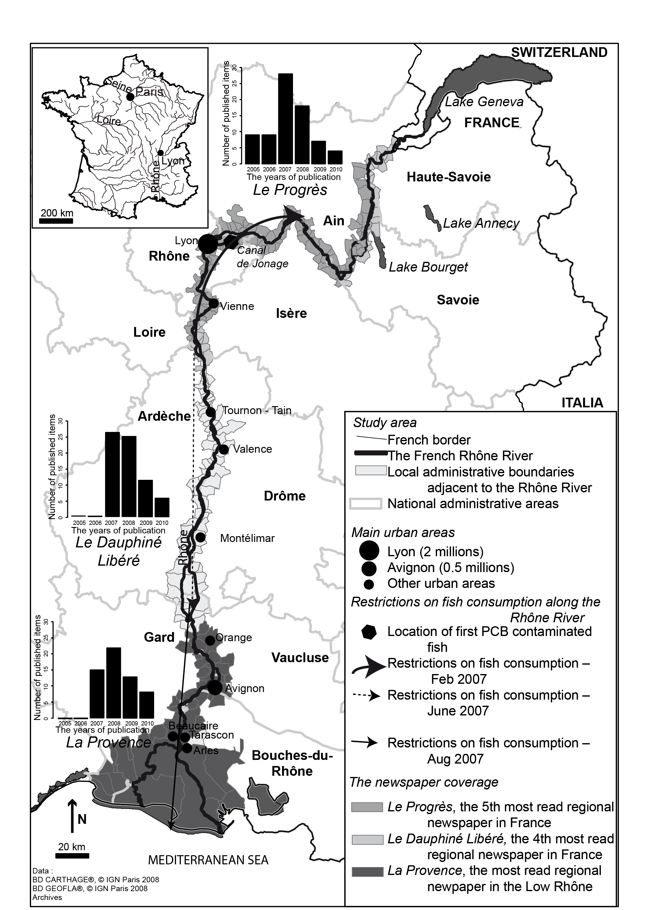
Figure 2.3: Development of chemical pollution when seen as a social problem: regional restrictions on fish consumption and marketing compared to the temporal patterns of media coverage about the PCB pollution in the Rhône River (2005-2010).

  - People’s values of waterways, from catchment to coast in South East Queensland, Australia
South East Queensland, Australia, has a rapidly growing population and spreading residential and industrial development. Urbanisation around the state capital of Brisbane has changed land use and increased ecological pressures on local waterways. Consequently, reduced biodiversity, and a detrimental impact on water quality has been observed, particularly downstream in the ecologically sensitive Moreton Bay, its marine park and islands. Often, research and management of landscapes that include terrestrial and marine components are treated independently, with an ecological bias. Studies that link human dimensions and values across places, particularly those that focus on the effects of upstream human activities on downstream environments, are rare (Alvarez-Romero et al., 2011; Halpern et al., 2009). Our qualitative research focuses on the values people hold about local waterways, comparing the values held at different spatial locations from the upper catchment to the sea.
Using semi-structured interviews, we examined the perceptions and experiences of key stakeholders using a typology of nature-related values devised by Kellert (1996, 2012). Kellert (2003) posits ten value types that describe people’s relationship with the natural world and proposes that values held about local places and ecologies can inform evaluation and management outcomes. Across the catchments, waterways were valued as places that bring people together where people derive pleasure, meaning and identity from their aquatic connections. In the upper and mid-catchments, waterways had strong heritage and place-related values arising from the longevity of farming traditions, intimating humanistic values. Aesthetic values were also important in the upper and mid-catchment, as beautiful places to live, farm and explore, while naturalistic values were dominant in the mid and lower catchments and in Moreton Bay, with waterways regarded as significant places to interact with nature whether fishing, diving, sailing or surfing. In the upper, rural catchment, waterways had a greater utilitarian value, signifying their use for water supply and irrigation for farming, while in the more urbanised lower catchment, people express moralistic and ecological values through experiential contact with nature and a desire to care for the waterways.
Implications for conservation relate to recognising that people hold diverse, and often combined, values towards these connected terrestrial, freshwater and marine areas. The strong sense of connection with nature offers new prospects for conservation management, indicating a constituency offering political support, or possible complaint processes may need to be established if specific values are infringed. Where current management is biophysically informed and concentrates on reducing certain forms of environmental damage from human actions, a values-based appreciation focused on people’s positive relationships with their waterways offers a way of building public support.
  - Connecting values of the marine environment
Engaging society with the sea is essential to achieve marine conservation objectives (Fletcher et al., 2012; Parsons et al., 2014). Efforts to engage society with conservation are often dominated by charismatic species (Simberloff, 1998) rather than more ecologically valuable species such as habitat forming species (Jefferson, 2010). Ecological values reflect those components of an ecosystem that ensure the functions and processes essential for ecological health can continue (Rapport, Costanza, & McMichael, 1998). Knowledge of societal values of the marine environment is limited; however, the prevalence of charismatic species in conservation engagement indicates that these may be the most socially valued ecosystem component. Focusing societal engagement efforts around charismatic species can lead to an oversimplification of conservation issues, a lack of connection between conservation issues and drivers, and policy spending being more strongly influenced by charisma than conservation need (Getzner, 2002). Environmental psychology approaches were applied to investigate the compatibility of social and ecological values of marine environments, and identify opportunities for engaging the public with less traditionally charismatic species and habitats.
A quantitative study of UK public perceptions of the marine environment (n = 1047) provided a greater understanding of society’s interpretations of marine health (Jefferson, Bailey, Laffoley, Richards, & Attrill, 2014). This revealed that gender influenced interest in marine species with males expressing stronger utilitarian values, illustrated by their greater interest in edible species and females stronger intrinsic values, with greater interest in colourful species. Additionally, social values, measured using a model based on Maslow’s Hierarchy of Needs, influenced perceptions of marine health with some audiences connecting more strongly with ecological components of marine health such as biodiversity, whilst others connected with visual indications such as water clarity (for fruther details, see Jefferson et al., 2014). The survey results suggest that marine conservation messages based on ecological values can be shaped to resonate with social values. For example, seagrass is an ecologically important species which is of low public interest (7% of respondents interested; Jefferson et al., 2014; Duffy, 2006). However, future engagement which incudes messages relating to the functions of seagrass (e.g., habitat provision, biodiversity support and improvement of water clarity) will enable the construction of stories which can resonate with multiple audiences. Additionally, messages which explain the essential role of seagrass in the life cycle of commercially important species (Heck, Hays, & Orth, 2003) would connect with the stronger utilitarian values expressed by males in the survey, whilst stories relating to the intrinsic values of seagrass will connect particularly with female audiences.
The environmental psychology approach of investigating public perceptions and interrogating socio-demographics, such as gender and social values variables, provided a detailed insight into public values of the sea, and into the heterogeneity of public audiences. This can enable efforts to establish stronger connections between society and the sea to have the greatest impact by shaping engagement approaches to specific audiences, and through a broader range of species than more traditional approaches may suggest. The best practice illustrated by this case study is the importance of understanding audience perceptions in order to deliver marine conservation engagement that both resonates with the audience and is underpinned by natural science principles.

  - Marine litter: The well-being costs of experiencing a littered shoreline

Marine litter is a universal issue. Defined as any persistent, manufactured or processed solid material that enters the marine environment (Galgani et al., 2010), marine litter contaminates environments from the poles to the equator and from the deep sea to the shoreline (Thompson, Moore, vom Saal, & Swan, 2009). Research has shown that litter can have harmful impacts on the environment and wildlife, such as through ingestion, entanglement, and changing entire ecosystems by transporting species to non-native environments (Hall, 2000; Kershaw, Katsuhiko, Lee, Leemseth, & Woodring, 2011). However, we know less about the impact of litter on people.
Environmental psychology studies have shown that people dislike litter; whether a beach is clean or littered plays an important role in deciding which beach to visit (Ballance, Ryan, & Turpie, 2000; Tudor & Williams, 2006). Previous research that explores the nature-human relationship has shown that clean coastlines can provide a range of benefits to people; such as people reporting feeling happier, healthier, and mentally restored (Ashbullby, Pahl, Webley, & White, 2013; Hipp & Ogunseitan, 2011). A related psychological theory is the Attention Restoration Theory (Kaplan & Kaplan, 1989), which states that mental fatigue and concentration can be enhanced by natural scenes, and facilitate positive experiences with nature. One study, however, has found that these properties, thus benefits, are not as pronounced when the environment is less pristine (Pretty, Peacock, Sellens, & Griffin, 2005). However, no research had explicitly examined the impact of litter specifically on people’s well-being, that is, how individuals think and feel about their lives (Dolan & White, 2008).
Using two quantitative studies, participants in southwest England (n = 79 and 19 respectively) viewed carefully manipulated coastal pictures that were either clean or had marine litter present. Using both quantitative and qualitative approaches, participants’ perceived restorativeness and affective responses to the images were examined (as reported in Wyles, Pahl, Thomas, & Thompson, 2015). Coastal scenes with rubbish were found to have harmful impacts on individuals’ well-being; eliciting negative emotional reactions (e.g., reported feeling sad) and, rather than having restorative qualities, respondents felt these littered images were detrimental to their overall well-being (Wyles et al., 2015). By demonstrating the well-being risk associated with marine litter, this case study further stresses the importance of conserving the aquatic environment by addressing the global issue of marine litter, which is harmful to not only the environment, but also to people who visit the coast. Environmental psychological solutions are especially encouraged, focusing on interventions that address the initial act of littering (understanding how and why the rubbish enters the environment in the first place) in addition to retrospective solutions (picking up the rubbish).

  - Local perceptions of environmental change in a community-based marine resource management setting

Fiji has a coastline of 1,129 km comprising over 330 islands, which represents a huge challenge for the collection of and access to fisheries information (Bell, Adams, Johnson, Hobday, & Gupta, 2011). Overfishing of coral reef areas is ubiquitous across this region, even in some remote traditional fishing areas used mainly for subsistence (Chin et al., 2011; King, 2005). The Government provides limited resources for quantifying impacts on fishing activities (Fiji Islands Government, 2010) and relies on the coastal communities for local governance (Chin et al., 2011; Mühlig-Hofmann, Veitayaki, Polunin, Stead, & Graham, 2004). However, the customary community structures needed for successful governance are eroding (e.g. chiefly presence on-site) with consequences for village leadership, clan-based resource ownership, decision-making structures and thus community-based fisheries management (Muehlig-Hofmann, 2007). For such data-scarce management to work (i.e. where little catch data is recorded), understanding resource users’ perceptions and behaviour is especially important (Breckwoldt & Seidel, 2012; Novaczek, Mitchell, & Veitayaki, 2005). This study investigated the perceptions and expectations of four communities on Gau, an offshore island which is directly dependent on its fisheries resources. A mixed-method approach using both quantitative and qualitative methods derived from ethnography, human geography and environmental psychology (including questionnaire surveys, life history interviews and participant observation), revealed perceptions on fishing activities, resource status, management and conservation efforts.
A perceived change in resource status and reduced abundance had led to an initial management plan on the island (Muehlig-Hofmann, 2007; Veitayaki, 2002). The management process was initiated by the local fishers and further developed by a team from the University of the South Pacific, in collaboration with Non-Governmental-Organisations. Introduced measures included the establishment of closed areas, and restrictions on fishing licenses, species size, gear and destructive fishing methods (e.g. use of plant poison). Most interviewees were satisfied with the present management level and there was a general confidence that the resource status would improve again with the introduction of closed areas. However, increasing numbers of fishers using modern spearguns and boats with longnets were expected in the future. The interdisciplinary approach of this study has helped to reveal the local perceptions of and expectations towards the introduced management measures, and has provided the local resource users with the opportunity to identify management challenges (for example, the high expectations of the effectiveness of closed areas).
With awareness of these expectations, possible scenarios can be drawn by the resource users for adapting their management and conservation efforts, for example turning a temporary closure area into a permanent one, or planning for the expected rise in spearfishing. This approach has been successfully used by the Fijian Locally Managed Marine Area Programme, to manage marine resources issues at a national scale (Govan, Comley, Tan, Guilbeaux, & Vave, 2011). Improved understanding of the links between perceptions, expectations and action, coupled with local ecological knowledge and resource monitoring, can improve the local ownership of the management process, including its assessment, adaptation and implementation.

  - Local acceptance of the offshore wind power – does design matter?
Switching our reliance from fossil to renewable energy sources such as offshore wind energy can help to limit further anthropogenic climate change. However, the impact of wind turbines on the landscape is often cited as reason for public unacceptability. To overcome resistance, participatory planning processes are recommended (Devine-Wright & Howes, 2010) in conjunction with landscape planning approaches that aim to create a regional meaning for projects, for example by placing the wind turbines parallel to the coast line to highlight its geographical shape (Arakawa, Ariga, & Iida, 2002; Schöbel, 2012).
This study attempted to empirically answer the question as to whether offshore wind farms that highlighted unique character of the landscape would be more acceptable by coastal residents than wind farms designed to maximise energy production only. An interdisciplinary, quantitative questionnaire survey was undertaken in four German coastal regions adjacent to the North Sea and Baltic Sea. Interviews were conducted in two regions, each with and without near shore wind farms, with approximately 100 residents per region. The participants answered questions on their attitudes towards offshore wind farms in general and towards six specific designs (Fig 2.4). Five of the designs were fictitious, based on distinct landscape features of the regions, and the sixth showed the actual technical design of a local offshore wind farm. Images used in the interviews showed each design as a bird’s-eye view and as seen from the coast in daylight and at night (see Schöbel, 2011).
Participants rated the region-specific wind farm designs as positive. However, when offered the choice between images of the actual technical and fictitious regional specific designs, on average participants rated their most preferred fictitious image only slightly more positively than the technical image. Differences existed between the regions; over half of Baltic Sea participants (62.4%) rated the technical design as their most preferred option. Although less distinct, the North Sea participants showed two most preferred choices; about one quarter preferred either the actual technical or the “Island” design (Fig. 2.4).
Clear opinions seemed to exist as regards the least preferred designs: of the North Sea participants, 61.7 % rejected the design simulating the international shipping route and for 70% of the Baltic Sea participants, the design mirroring the area of the local national park was their least preferred option. The most frequently (23.2 %) cited reason against the “shipping route” design was connected to the fear of navigation dangers and not aesthetics. Further work should attempt to expand on the reasons that underpin preference for certain wind farm designs.
These results provide evidence that design does seem to matter in generating public acceptability of offshore wind farms, however concerns about maritime safety appear to override design preferences and need to be addressed in order to foster acceptability. Further work to better understand the factors that underpin preference of wind farm designs could encourage levels of acceptability of offshore wind farms necessary to meet emissions targets.

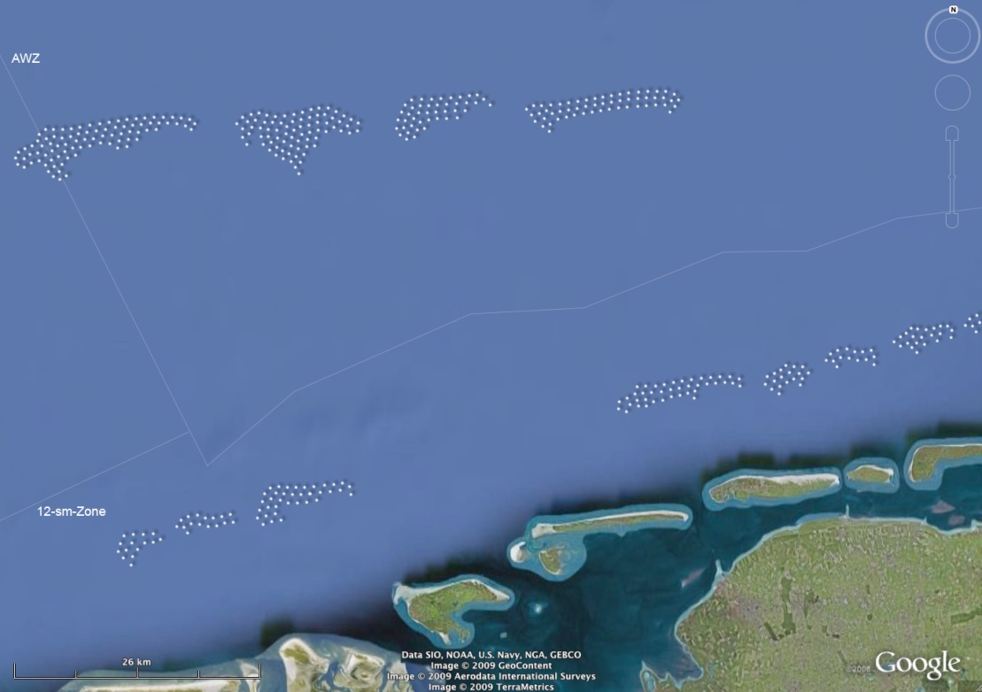

Figure 2.4: An example for the North Sea wind farm designs was the “Island” solution. This design placed the wind turbines in such a way that they represented the old coastal line destroyed by a flood in early medieval times (Schöbel, 2011).

- Discussion
The nine case studies illustrate the application of environmental psychology approaches to a diverse range of aquatic management issues and scales. In each case, environmental psychology has provided greater insight into the societal connections with and perceptions of the ecosystem, species or environmental issues in question. In turn, this insight facilitates managers to act with greater agency when engaging multiple stakeholders and perspectives which must be balanced in order to identify and implement effective management options. In this section, emergent themes on audience perception of aquatics environments at various scales are discussed, and an overview of the applications of environmental psychology studies in aquatic management are given. This is followed by a discussion of the contribution of the case studies to the key societal management challenges for aquatic environments raised at the beginning of the paper. Finally, a future perspective is given of how environmental psychology studies can be encouraged and have maximum benefit for aquatic management.
The case studies examined national, regional and local scales in order to identify factors that drive perceptions and attitudes to specific aquatic environments. At the local scale, factors such as place attachment (i.e. how people form bonds with places, see Altman & Low, 1992) were also investigated to decipher the impact of emotional bonds with the environment. The benefits of understanding the societal implications of governance decisions were highlighted, with reference to remote communities that directly depend on natural resources. Moreover, the impact of the environment on human well-being is examined with reference to the UK’s coastline. The value of the media in the dissemination of ecological messages is discussed alongside the relative importance of knowledge and values in determining the public assessment of conservation importance.
The human element of the natural environment is increasingly recognised as the least well understood component of any ecosystem, whilst simultaneously, human actions can have the greatest impact on whether sustainable management of the natural environment is realised (Mascia et al., 2003). Many of the case studies illustrate how environmental psychology can be integrated into management plans, alongside a natural science understanding of the issues. It is important to clarify that the authors do not extol the use of environmental psychology methods in isolation, but call for greater connectivity and the adoption of a joined up approach to combine the strengths of both natural and social sciences to inform better management of natural resources. The case studies within this paper give examples of how integrating environmental psychology approaches with natural science principles can help to overcome the key societal management challenges mentioned in the beginning of this paper (Klein et al., 2008; Leslie & McLeod, 2007; McKinley & Fletcher, 2012; Vincent, 2011) and aid in achieving sustainable management outcomes (Table 2). The contributions of the case studies to each challenge are then discussed in the following text.

 | Societal Management Challenges in Aquatic Environments
Case Study | Engaging Stakeholders in management | Engaging large and public audiences | Balancing differing values of aquatic resources | Understanding connections between society and aquatic systems
2.1 | x |  | x | x
2.2 | x |  | x | x
2.3 |  |  | x | x
2.4 |  | x |  | x
2.5 | x | x | x | x
2.6 |  | x | x | x
2.7 |  | x |  | x
2.8 | x |  | x | x
2.9 |  | x | x | x

Table 2: The contribution of each case study of this paper to the four key societal management challenges in the aquatic environment.
3.1 Engaging Stakeholders in Management
The application of environmental psychology approaches to support efforts to engage stakeholders in management is shown by four of the case studies. Case studies 2.1 and 2.2 illustrate how an understanding of stakeholder attitudes enables environmental managers to connect with different stakeholders in ways that resonate with the target audience. Case study 2.5 and 2.8 further exemplify this approach buy giving additional examples in Fiji and Australia of the how more effective and sustainable aquatic management can be implemented when stakeholder attitudes are better understood and integrated into management decisions.
3.2 Engaging large and public audiences
Many of the conservation challenges in aquatic environments require the engagement of large audiences to respond to the scale of problems faced in this arena, and five of the case studies in this paper document how this could be achieved. Our case studies show that environmental psychology method can be applied on a large scale to inform the wider public debate about the management of aquatic resources. For example, case study 2.4 documents how conservation issues can be transformed through a media lens and disseminated to the wider audience, allowing environmental managers to engage with the media and communicate widely. Case study 2.5 shows how environmental psychology can engage the public at the scale of the catchment, combining the challenges associated with freshwater and marine environments. Case studies 2.6, 2.7 and 2.9 all give further examples of the use of environmental psychology in engaging large and disparate audiences, in the marine environment. These case studies exemplify the benefits of environmental psychology methods in engaging with large audience who express a range of attitudes and environmental values based on a variety of use of the marine environment, to give insights on the drivers influencing the perspectives held by these public audiences.
3.3 Balancing differing values of aquatic resources
Resource management in the aquatic environment is challenging given the variety of resources and the numbers of stakeholders and publics involved. The environmental psychology approaches used in the five of the case studies show how valuable such approaches can be. Case study 2.8 identifies the issues surrounding local governance of marine resources in order to identify barriers to sustainable resource management. In doing so, management strategies were then implemented that took account of the community’s needs and expectations in addition to ecological pressures. In case study 2.9, public perceptions of wind farm design identified positive features in addition to barriers to acceptability; used in the early stages of wind farm development, this could be a key method to minimise opposition to such development. Finally, case study 2.5 indicates that the value of aquatic resources within the same unit of geographical measurement (i.e. the catchment) can be highly variable, creating new challenges for managing aquatic environments at this spatial scale.
3.4 Understanding connections between society and aquatic systems
A key strength of environmental psychology is to provide a deeper understanding of the human-environment relationship and the drivers behind the interactions and attitudes that affect this relationship (Table 2). All nine case studies contribute to a better understanding of the societal connections with aquatic ecosystems by interrogating and unpacking the values attributed to the aquatic environment. In case studies 2.3 and 2.6, identifying the values attributed to key aquatic species allow environmental managers and experts to see conservation goals from new perspectives and create more robust management decisions. Case study 2.7 identifies barriers to the use of the marine seascape, highlighting how an individual’s experiences of and well-being benefit associated with aquatic environments can be influenced by external factors.
Looking towards the future, the authors believe it is vital that the benefits of environmental psychology approaches are broadly distributed, both within academia and to wider audiences including environmental managers. This will necessitate more effective relationships between academics and practitioners in conjunction with increased efforts by academics to disseminate findings more widely than peer-reviewed journals that remain relatively inaccessible to those outside academia. Many of the issues surrounding interdisciplinary research between social scientists and natural scientists documented by Fox et al. (2006) continue to exist between academics and practitioners. However, certain barriers, such as limited opportunities for interdisciplinary collaboration, are beginning to be resolved through funding opportunities such as the Natural Environment Research Council’s (NERC) Valuing Nature fellowship, which aims to encourage ‘discipline hopping’ between social and natural sciences and the wider Valuing Nature programme which draws together natural sciences, social sciences, arts and humanities research and practice. Such opportunities should be widened to encourage academics and practitioners to foster relationships that would speed the process of information sharing and dissemination.
The key message that flows throughout all of the case studies presented here is that environmental psychology is an effective and appropriate discipline to be used in environmental management research and is able to inform environmental management practices across a range of aquatic environments and scenarios. It can provide insight into how people connect with nature and wider management issues, and this insight provides considerable benefit in helping to overcome barriers that are currently faced by environmental managers.
- Conclusions
Environmental psychology approaches provide tools to facilitate better management and governance of aquatic environments which goes beyond the protection of aquatic species and ecosystems by engaging stakeholder and public audiences. In this sense environmental psychology, as demonstrated by the case studies, support the delivery of management objectives that meet both societal needs and ecological goals. Moreover, environmental psychology enables the provision of science that meets public expectations, that furthers knowledge about topics with societal importance, providing a bridge between science and policy (Lubchenco, 1998).
A continuing challenge is to increase engagement between policy makers and environmental psychologists, which has begun to occur, for example through reports such as NERC’s Living With Environmental Change report or the UKERC Energy Transformation project (Parkhill, Demski, Butler, Spence, & Pidgeon, 2013; Upham et al., 2009). Building up relationships between these traditionally distinct disciplines enables the cross-fertilisation of ideas and allows novel methodologies to be trialled and adopted by the wider academic community. In this way, environmental psychology can develop in order to actively contribute to the environmental management challenges that will be faced in the future. The authors hope that the current enthusiasm for integrating social sciences into environmental management will continue.
Acknowledgements
The authors would like to thank the organisers of the 10th Biennial Conference on Environmental Psychology, the hosts Universität Magdeburg and the delegates who attended and contributed to the symposia on Public Perceptions of Aquatic Environments. The authors woud lke to thank the two anonymous reviewers for their comments to improve the manuscript.
Case study 2.1 was developed in context of the Doctoral School of Sustainable Development (dokNE) at the University of Natural Resources and Life Sciences, Vienna.
Case Study 2.2 was completed in June 2006, at a summer school bringing together researchers and doctoral students of the University of Florence (Italy) and the University of Lyon (France). Data analysis was funded by the ANR GESTRANS project granted to Alain Recking.
Case Study 2.3 was funded through a joint NERC-ESRC PhD studentship, supervised by Dr Jose Constantine; Dr Lorraine Whitmarch and Prof. Steve Ormerod at the University of Cardiff.
Case Study 2.4 was supported by the Zone Atelier Bassin du Rhône (ZABR) and Rhône Méditerranée and Corse Water Agency (Action 33, Project:Mieux comprendre les discours de crise sur le fleuve Rhône: extrêmes hydrologiques et plantes invasives). It was conducted within the Observatoire Hommes-Milieux (OHM) Vallée du Rhône
Case Study 2.7 was funded by an Economic and Social Research Council (ESRC) / Natural Environment Research Council (NERC) Interdisciplinary Studentship Scheme [grant number: ES/I004130/1].
Case study 2.6 was funded by Naturla England and the Higher Education Innovation Fund.
Case study 2.9 was associated with the RAVE (Research of Alpha Ventus) project and funded by the German Federal Ministry for Economic Affairs and Energy (FKZ: 0325137). Cooperation partners: Technical Universities of Berlin and Munich, University of Applied Sciences Bremerhaven. For research reports see www.akzeptanz-windenergie.de
References
Altman, I., & Low, S. (1992). Place Attachment (Human Behaviour and Environment New York, NY: Springer.
Alvarez-Romero, J. G., Pressey, R. L., Ban, N. C., Vance-Borland, K., Willer, C., Klein, C. J., & Gaines, S. D. (2011). Integrated Land-Sea Conservation Planning: The Missing Links. Annual Review of Ecology, Evolution, and Systematics, 42, 381-409. doi:10.1146/annurev-ecolsys-102209-144702
Arakawa, C., Ariga, S., & Iida, M. (2002). Proposal of vernacular design for wind turbine. Journal of Wind Engineering and Industrial Aerodynamics, 90(12-15), 1731-1741. doi:10.1016/s0167-6105(02)00283-0
Ashbullby, K. J., Pahl, S., Webley, P., & White, M. P. (2013). The beach as a setting for families' health promotion: A qualitative study with parents and children living in coastal regions in Southwest England. Health & Place, 23, 138-147. doi:10.1016/j.healthplace.2013.06.005
Ballance, A., Ryan, P. G., & Turpie, J. K. (2000). How much is a clean beach worth? The impact of litter on beach users in the Cape Peninsula, South Africa. South African Journal of Science, 96(5), 210-213.
Bauer, N., Wallner, A., & Hunziker, M. (2009). The change of European landscapes: Human-nature relationships, public attitudes towards rewilding, and the implications for landscape management in Switzerland. Journal of Environmental Management, 90(9), 2910-2920. doi:10.1016/j.jenvman.2008.01.021
Bechtel, R., & Churchman, A. (2002). Handbook of Environmental Psychology. New York: Wiley.
Bell, J. D., Adams, T. J. H., Johnson, J. E., Hobday, A. J., & Gupta, A. S. (2011). Implications of climate change for contributions by fisheries and aquaculture to Pacific Island economies and communities. In J. D. Bell, J. E. Johnson, & A. J. Hobday (Eds.), Vulnerability of Tropical Pacific Fisheries and Aquaculture to Climate Change (733-801). Noumea, New Caledonia: Secretariat of the Pacific Community.
Berkes, F. (2004). Rethinking community-based conservation. Conservation Biology, 18(3), 621-630. doi:10.1111/j.1523-1739.2004.00077.x
Braito, M., Böck, K., Flint, C., Muhar, A., Muhar, S., & Penker, M. (in review). Human-Nature Relationships and the Complexity of Environmental Behaviour. Environmental Values.
Breckwoldt, A., & Seidel, H. (2012). The need to know what to manage - community-based marine resource monitoring in Fiji. Current Opinion in Environmental Sustainability, 4(3), 331-337. doi:10.1016/j.cosust.2012.05.008
Brooks, J., Waylen, K. A., & Mulder, M. B. (2013). Assessing community-based conservation projects: A systematic review and multilevel analysis of attitudinal, behavioural, ecological and economic outcomes. Environmental Evidence, 2(2), 1-34 doi:10.1186/2047-2382-2-2
Chin, A., Lison de Loma, T., Reytar, K., Planes, S., Gerhardt, K., Clua, E., . . . Wilkinson, C. (2011). Status of Coral Reefs of the Pacific and Outlook: 2011. Retrieved January 15, 2014, from http://researchonline.jcu.edu.au/24292/
Comby, E., Le Lay, Y. F., & Piegay, H. (2014). How chemical pollution becomes a social problem. Risk communication and assessment through regional newspapers during the management of PCB pollutions of the Rhone River (France). The Science of the total environment, 482-483, 100-115. doi:10.1016/j.scitotenv.2014.02.137
Cottet, M., Piegay, H., & Bornette, G. (2013). Does human perception of wetland aesthetics and healthiness relate to ecological functioning? Journal of Environmental Management, 128, 1012-1022. doi:10.1016/j.jenvman.2013.06.056
de Groot, M., & de Groot, W. T. (2009). "Room for river" measures and public visions in the Netherlands: A survey on river perceptions among riverside residents. Water Resources Research, 45, 1-11. doi:10.1029/2008wr007339
De Young, R. (2013). Environmental Psychology Overview. In S. R. Klein & A. H. Hauffman (Eds.), Green Organisations: Driving Change with IO Psychology (pp. 17-33). New York: Routledge.
Devine-Wright, P., & Howes, Y. (2010). Disruption to place attachment and the protection of restorative environments: A wind energy case study. Journal of Environmental Psychology, 30(3), 271-280. doi:10.1016/j.jenvp.2010.01.008
Dolan, P., & White, M. P. (2008). How can measures of subjective well-being be used to inform public policy? Perspectives on Psychological Science, 2(1), 71-85. doi: 10.1111/j.1745-6916.2007.00030.x
Dudgeon, D., Arthington, A. H., Gessner, M. O., Kawabata, Z.-I., Knowler, D. J., Leveque, C., . . . Sullivan, C. A. (2006). Freshwater biodiversity: importance, threats, status and conservation challenges. Biological Reviews, 81(2), 163-182. doi:10.1017/s1464793105006950
Fiji Islands Government. (2010). Fiji’s Fourth National Report to the United Nations Convention on Biological Diversity (CBD). Fiji: Department for the Environment.
Fischer, A., & van der Waal, R. (2007). Invasive plant suppresses charismatic seabird - the construction of attitudes towards biodiversity management options. Biological Conservation, 135(2), 256-267. doi:10.1016/j.biocon.2006.10.026
Fletcher, S., Jefferson, R., & McKinley, E. (2012). Exploring the shallows: a response to Saving the shallows: focusing marine conservation where people might care. Aquatic Conservation-Marine and Freshwater Ecosystems, 22(1), 7-10. doi:10.1002/aqc.2220
Flint, C. G., Kunze, I., Muhar, A., Yoshida, Y., & Penker, M. (2013). Exploring empirical typologies of human-nature relationships and linkages to the ecosystem services concept. Landscape and Urban Planning, 120, 208-217. doi:10.1016/j.landurbplan.2013.09.002
Fox, H. E., Christian, C., Nordby, J. C., Pergams, O. R. W., Peterson, G. D., & Pyke, C. R. (2006). Perceived barriers to integrating social science and conservation. Conservation Biology, 20(6), 1817-1820. doi:10.1111/j.1523-1739.2006.00598.x
Galgani, F., Fleet, D., Van Franeker, J., Katsanevakis, S., Maes, T., Mouat, J., & Janssen, C. (2010). Marine Strategy Framework Directive: Task Group 10 Report Marine Litter. Retrieved September 11, 2015, from http://ec.europa.eu/environment/marine/pdf/9-Task-Group-10.pdf
Getzner, M. (2002). Investigating public decisions about protecting wetlands. Journal of Environmental Management, 64(3), 237-246. doi:10.1006/jema.2001.0471
Gifford, R. (2007. Environmental Psychology: Principles and Practice (4th ed.). Canada: Optimal Books.
Govan, H., Comley, J., Tan, W., Guilbeaux, M., & Vave, R. (2011). Recommendations from Ten Years of Monitoring under the LMMA Network’s Learning Framework. Retrieved September 11, 2015, from http://www.lmmanetwork.org/files/govan_et_al_2011_lc_recommendations.pdf
Halpern, B. S., Ebert, C. M., Kappel, C. V., Madin, E. M. P., Micheli, F., Perry, M., . . . Walbridge, S. (2009). Global priority areas for incorporating land-sea connections in marine conservation. Conservation Letters, 2(4), 189-196. doi:10.1111/j.1755-263X.2009.00060.x
Halpern, B. S., Walbridge, S., Selkoe, K. A., Kappel, C. V., Micheli, F., D'Agrosa, C., . . . Watson, R. (2008). A global map of human impact on marine ecosystems. Science, 319(5865), 948-952. doi:10.1126/science.1149345
Hall, K. (2000). Impacts of marine debris and oil: economic & social costs to coastal communities. Shetland: Kommunenes Internasjonale Miljøorganisasjon.
Harley, C. D. G., Hughes, A. R., Hultgren, K. M., Miner, B. G., Sorte, C. J. B., Thornber, C. S., . . . Williams, S. L. (2006). The impacts of climate change in coastal marine systems. Ecology Letters, 9(2), 228-241. doi:10.1111/j.1461-0248.2005.00871.x
Heck, K. L., Hays, G., & Orth, R. J. (2003). Critical evaluation of the nursery role hypothesis for seagrass meadows. Marine Ecology Progress Series, 253, 123-136. doi:10.3354/meps253123
Hipp, A. J., & Ogunseitan, O. A. (2011). Effect of environmental conditions on perceived psychological restorativeness of coastal parks. Journal of Environmental Psychology, 31(4), 421-429. doi:10.1016/j.jenvp.2011.08.008
House, M. A., & Sangster, E. K. (1991). Public perception of river-corridor management. Journal of the Institution of Water and Environmental Management, 5(3), 312-317.
ISSC & UNESCO. (2013). World Social Science Report 2013: Changing Global Environments. Paris: OECD Publishing and UNESCO Publishing.
Jefferson, R. L. (2010). Communicating marine environmental health: connecting science, social and policy values (unpublished doctoral dissertation). University of Plymouth, Plymouth, UK.
Jefferson, R. L., Bailey, I., Laffoley, D. d. A., Richards, J. P., & Attrill, M. J. (2014). Public perceptions of the UK marine environment. Marine Policy, 43, 327-337. doi:http://dx.doi.org/10.1016/j.marpol.2013.07.004
Jiménez-Castillo, D., & Ortega-Egea, J. M. (2015). Too positive to change? Examining optimism bias as a barrier to media effects on environmental activism. Journal of Environmental Psychology, 43, 216-225. doi:http://dx.doi.org/10.1016/j.jenvp.2015.07.004
Kaplan, R. (1977). Down by the Riverside: Informational Factors in Waterscape Preference. Paper presented at the Proceedings of River Recreation Management & Research Symposium, Minneapolis, USA.
Kaplan, R., & Kaplan, S. (1989). The experience of nature: a psychological perspective. New York: Cambridge University Press.
Kellert, S. R. (1996). The Value of Life: Biological Diversity and Human Society. Washington DC: Island Press.
Kellert, S. R. (2003). Human values, ethics and the marine environment. In D. G. Dallmeyer (Ed.), Values at Sea: Ethics for the Marine Environment (pp.1-18). Athens and London: The University of Georgia Press.
Kellert, S. R. (2012). Birthright: people and nature in the modern world. New Haven: Yale University Press.
Kershaw, P., Katsuhiko, S., Lee, S., Leemseth, J., & Woodring, D. (2011). Plastic debris in the ocean. In T. Goverse & S. Bech (Eds.), UNEP year book: emerging issues in our environment (pp. 21-33). Nairobi, Kenya: UNEP (United Nations Environment Programme).
King, M. (2005). Problems with Centralised Fisheries Management in Pacific Islands. In N. Kishigami & J. M. Savelle (Eds.), Indigenous Use and Management of Marine Resources (pp. 181-195). Osaka, Japan: The National Museum of Ethnology.
Klein, C. J., Chan, A., Kircher, L., Cundiff, A. J., Gardner, N., Hrovat, Y., . . . Airame, S. (2008). Striking a balance between biodiversity conservation and socioeconomic viability in the design of marine protected areas. Conservation Biology, 22(3), 691-700. doi:10.1111/j.1523-1739.2008.00896.x
Kollmuss, A., & Agyeman, J. (2002). Mind the Gap: Why do people act environmentally and what are the barriers to pro-environmental behavior? Environmental Education Research, 8(3), 239-260. doi:10.1080/13504620220145401
Lane, E. W. (1957). A study of the shape of channels formed by natural streams flowing in erodable material. Omaha, Nevada: U.S Army Engineer Division, Missouri River, Corps of Engineers.
Le Lay, Y.-F., Cottet, M., Piégay, H., & Rivière-Honegger, A. (2012). Ground imagery and environmental perception: Using photo-questionnaires to evaluate river management strategies. In C. P. & P. H. (Eds.), Fluvial remote sensing for science and management (pp. 405-429). Chichester: Wiley-Blackwell.
Le Lay, Y.-F., Piegay, H., & Riviere-Honegger, A. (2013). Perception of braided river landscapes: Implications for public participation and sustainable management. Journal of Environmental Management, 119, 1-12. doi:10.1016/j.jenvman.2013.01.006
Leslie, H. M., & McLeod, K. L. (2007). Confronting the challenges of implementing marine ecosystem-based management. Frontiers in Ecology and the Environment, 5(10), 540-548. doi:10.1890/1540-9295(2007)5[540:ctcoim]2.0.co;2
Lorimer, J. (2007). Nonhuman charisma. Environment and Planning D-Society & Space, 25(5), 911-932. doi:10.1068/d71j
Lubchenco, J. (1998). Entering the century of the environment: A new social contract for science. Science, 279(5350), 491-497. doi:10.1126/science.279.5350.491
Malmqvist, B., & Rundle, S. (2002). Threats to the running water ecosystems of the world. Environmental Conservation, 29(2), 134-153. doi:10.1017/s0376892902000097
Mascia, M. B., Brosius, J. P., Dobson, T. A., Forbes, B. C., Horowitz, L., McKean, M. A., & Turner, N. J. (2003). Conservation and the social sciences. Conservation Biology, 17(3), 649-650. doi:10.1046/j.1523-1739.2003.01738.x
McKinley, E., & Fletcher, S. (2012). Improving marine environmental health through marine citizenship: A call for debate. Marine Policy, 36(3), 839-843. doi:10.1016/j.marpol.2011.11.001
Moller, H., Berkes, F., Lyver, P. O., & Kislalioglu, M. (2004). Combining science and traditional ecological knowledge: Monitoring Populations for co-management. Ecology and Society, 9(3). Retrieved September 11, 2015, from http://www.ecologyandsociety.org/vol9/iss3/art2/
Monod, G., Devaux, A., & Riviere, J. L. (1988). Effects of chemical pollution on the activities of hepatic xenobiotic metabolizing enzymes in fish from the river Rhone. Science of the Total Environment, 73(3), 189-201. doi:10.1016/0048-9697(88)90428-7
Mosley, M. P. (1989). Perceptions of New Zealand River Scenery. New Zealand Geographer, 45(1), 2-13. doi:10.1111/j.1745-7939.1989.tb01485.x
Muehlig-Hofmann, A. (2007). Traditional authority and community leadership: key factors in community-based marine resource management and conservation. SPC Traditional Marine Resourse Management Knowledge Information Bulletin, 21, 31-44.
Munoz, J. (2007). Biodiversity conservation including uncharismatic species. Biodiversity and Conservation, 16(7), 2233-2235. doi:10.1007/s10531-006-9147-1
Mühlig-Hofmann, A., Veitayaki, J., Polunin, N. V. C., Stead, S., & Graham, N. A. J. (2004). Community-based marine resource management in Fiji – from yesterday to tomorrow. Paper presented at the 10th International Coral Reef Symposium, Okinawa, Japan.
Novaczek, I., Mitchell, J., & Veitayaki, J. (2005). Pacific Voices — Equity and Sustainability in Pacific Island Fisheries. Suava, Fiji: Institute of Pacific Studies, University of the South Pacific.
Ormerod, S. J., Dobson, M., Hildrew, A. G., & Townsend, C. R. (2010). Multiple stressors in freshwater ecosystems. Freshwater Biology, 55, 1-4. doi:10.1111/j.1365-2427.2009.02395.x
Parkhill, K. A., Demski, C., Butler, C., Spence, A., & Pidgeon, N. (2013). Transforming the UK Energy System: Public Values, Attitudes and Acceptability - Synthesis Report. Retrieved September 11, 2015, from http://www.ukerc.ac.uk/publications/transforming-the-uk-energy-system-public-values-attitudes-and-acceptability.html
Parsons, E. C. M., Favaro, B., Draheim, M., McCarthy, J.-B., Aguirre, A., Bauer, A. L., . . . Wright, A. J. (2014). 71 Questions of global importance for the conservation of marine biological diversity. Conservation Biology 28(5), 1206-1214. doi: 10.1111/cobi.12303
Polidoro, B. A., Carpenter, K. E., Collins, L., Duke, N. C., Ellison, A. M., Ellison, J. C., . . . Yong, J. W. H. (2010). The Loss of Species: Mangrove Extinction Risk and Geographic Areas of Global Concern. Plos One, 5(4). doi:10.1371/journal.pone.0010095
Pretty, J., Peacock, J., Sellens, M., & Griffin, M. (2005). The mental and physical health outcomes of green exercise. International Journal of Environmental Health Research, 15(5), 319-337. doi:10.1080/09603120500155963
Rapport, D. J., Costanza, R., & McMichael, A. J. (1998). Assessing ecosystem health. Trends in Ecology & Evolution, 13(10), 397-402. doi:10.1016/s0169-5347(98)01449-9
Raymond, C. M., Fazey, I., Reed, M. S., Stringer, L. C., Robinson, G. M., & Evely, A. C. (2010). Integrating local and scientific knowledge for environmental management. Journal of Environmental Management, 91(8), 1766-1777. doi:10.1016/j.jenvman.2010.03.023
Sandbrook, C., Adams, W. M., Buscher, B., & Vira, B. (2013). Social Research and Biodiversity Conservation. Conservation Biology, 27(6), 1487-1490.
doi:10.1111/cobi.12141
Saunders, C. D. (2003). The Emerging Field of Conservation Psychology. Human Ecology Review, 10(2), 137-149.
Schultz, P. W. (2011). Conservation Means Behavior. Conservation Biology, 25(6), 1080-1083. doi:10.1111/j.1523-1739.2011.01766.x
Schöbel, S. (2012). Windenergie und Landschaftsästhetik: Zur landschaftsgerechten Anordnung von Windfarmen. Berlin: Jovis.
Simberloff, D. (1998). Flagships, umbrellas, and keystones: Is single-species management passé in the landscape era? Biological Conservation, 83(3), 247-257. doi:10.1016/s0006-3207(97)00081-5
Spence, A., Poortinga, W., Butler, C., & Pidgeon, N. F. (2011). Perceptions of climate change and willingness to save energy related to flood experience. Nature Climate Change, 1(1), 46-49. doi:10.1038/nclimate1059
Strayer, D., L., & Dudgeon, D. (2010). Freshwater biodiversity conservation: recent progress and future challenges. Journal of the North American Benthological Society, 29(1), 244-258.
Thompson, R. C., Moore, C. J., vom Saal, F. S., & Swan, S. H. (2009). Plastics, the environment and human health: current consensus and future trends. Philosophical Transactions of the Royal Society B-Biological Sciences, 364(1526), 2153-2166. doi:10.1098/rstb.2009.0053
Tudor, D. T., & Williams, A. T. (2006). A rationale for beach selection by the public on the coast of Wales, UK. Area, 38(2), 153-164. doi: 10.1111/j.1475-4762.2006.00684.x
UNEP (2006). Marine and coastal ecosystems and human well-being: A synthesis report based on the findings of the Millennium Ecosystem Assessment. Retrieved September 11, 2015, from http://www.unep.org/pdf/Completev6_LR.pdf
Upham, P., Whitmarsh, L., Poortinga, W., Purdam, K., Darnton, A., McLachlan, C., & Devine-Wright, D. (2009). Public Attitudes to Environmental Change: a selective review of theory and practice. Retrieved from http://www.esrcsocietytoday.ac.uk/ESRCInfoCentre/Images/Public Attitudes to Environmental Change_exec summary_tcm6-35479.pdf
Veitayaki, J. (2002). Taking advantage of indigenous knowledge: the Fiji case. International Social Science Journal, 54(3), 395. doi:10.1111/1468-2451.00391
Vincent, A. C. J. (2011). Saving the shallows: focusing marine conservation where people might care. Aquatic Conservation-Marine and Freshwater Ecosystems, 21(6), 495-499. doi:10.1002/aqc.1226
Walker-Springett, K. (2014). The Development of Integrated Conservation Strategies based on Environmental Science and Psychology: A Case Study of the Freshwater Pearl Mussel (unpublished doctoral dissertation). University of Cardiff, Cardiff, UK.
White, M. P., Alcock, I., Wheeler, B. W., & Depledge, M. H. (2013). Coastal proximity, health and well-being: Results from a longitudinal panel survey. Health & Place, 23, 97-103. doi:10.1016/j.healthplace.2013.05.006
Worm, B., Barbier, E. B., Beaumont, N., Duffy, J. E., Folke, C., Halpern, B. S., . . . Watson, R. (2006). Impacts of biodiversity loss on ocean ecosystem services. Science, 314(5800), 787-790. doi:10.1126/science.1132294
Wyles, K. J., Pahl, S., Thomas, K., & Thompson, R. C. (2015). Factors that can undermine the psychological benefits of coastal environments: exploring the effect of tidal state, presence and type of litter. Environment and Behaviour [online]. doi:10.1177/0013916515592177

