Investigation of the Properties of Icy Lunar Polar Regolith Simulants

Craig Pitcher^{a,*}, Norbert Kömle^{b}, Otto Leibniz^{c}, Odalys Morales-Calderon^{c}, Yang Gaoª, Lutz Richter^{d}

ªSTAR Lab, Surrey Space Centre, University of Surrey, Guildford, GU2 7XH, UK
^{b}Space Research Institute, Austrian Academy of Sciences, Schmiedlstraße 6, A-8042 Graz, Austria
^{c}Institute for Soil Mechanics and Foundation Engineering, Geotechnical Laboratory, Graz University of Technology, Rechbauerstrasse 12, A-8010 Graz, Austria
^{d}OHB System AG, Perchtinger Straße 5, 81379 Munich, Germany

Abstract

As icy regolith is believed to exist in the subsurface of permanently shadowed areas near the lunar south pole, there is a growing interest in obtaining samples from these polar regions. To qualify for spaceflight, sampling instruments must demonstrate their ability to operate in the expected environment. However, there is currently no quantitative data detailing the extent and distribution of ice in polar regolith. While work has been done to determine the effects of water ice content in simulants such as JSC-1A, to date there has been no investigation into the properties of icy simulants of the regolith believed to be found at lunar polar regions. A series of experiments has therefore been conducted to determine the properties of icy NU-LHT-2M lunar highland simulant, an approximation of lunar polar regolith, at varying degrees of saturation. A number of procedures for preparing the simulant were tested, with the aim of defining a standardised technique for the creation of icy simulants with controlled water contents. Saturation of the highland simulant was found to occur at a water mass content between 13% and 17%, while cone penetration tests demonstrated that a significant increase in penetration resistance occurs at 5 ± 1%. Uniaxial compression tests showed an increase in regolith strength with water mass and density, which slows down as the saturation level is reached. The results presented here demonstrate the first characterisation of the properties of icy lunar polar regolith simulants, which can be expanded upon to further the understanding of its properties for use in future instrumentation testing.

Keywords: lunar simulants, icy regolith, polar simulant, preparation methods, saturation

1. Introduction

There is significant evidence to suggest that vast quantities of water ice and other volatiles exist within the subsurface of the lunar regolith at the poles, particularly in the permanently shadowed areas near the south pole. The LCROSS mission indicated concentrations of water ice at the impact site of 5.6 ± 2.9% by mass (Colaprete et al, 2010; Mitrofanov et al, 2010). It is believed that the ice here may be in the form of particles, ice-cemented regolith or ice blocks. Other measurements have also shown the existence of water adsorbed at the surface in numerous other locations (Hegde et al, 2012). The existence of these volatiles would be incredibly beneficial for future lunar activities and exploration, given their potential for use as an inexpensive source of propellants and other consumables. As a result, confirming these findings by directly investigating the lunar regolith in situ is a major goal of future lunar exploration.
However, before such a mission can be flown, stringent tests must be performed on its subsystems and instruments to determine their ability to operate in the extreme environmental conditions that will be encountered. One such subsystem is the Lunar Generic Regolith Acquisition/Sampling Paw (L-GRASP), a sampling device currently being developed by the companies SELEX and OHB on behalf of the European Space Agency (ESA), which is designed for taking samples from a lunar polar site (Richter et al, 2013). As part of these tests, it is necessary to use simulants which mimic in the best possible way the icy regolith that will be interacted with.
More than 30 lunar regolith simulants have been developed in the past (Taylor, 2010). The first to be created was the MLS-1 lunar mare analogue, designed to match as closely as possible the mineralogy, chemistry and texture of the simulated material (Seiferlin et al, 2008). After the Lunar Simulant Working Group had identified the need for a material to be developed for use in engineering studies in support of future lunar activities, NASA’s Johnson Space Centre developed the JSC-1 simulant. This is a glass-rich, basaltic ash mined from a volcanic ash deposit in the San Francisco volcano field, designed to approximate the properties of the lunar mare soil found at the Apollo 14 site and to complement the MLS-1 (McKay et al, 1994). After its depletion, JSC-1A was developed as a direct replacement, matching as closely as possible the original JSC-1, with AF and AC versions approximating components of the regolith with finer and coarser grain sizes, respectively (Orbitec, 2007).
More recently, NASA has developed various versions of a lunar highland simulant, the NU-LHT series, in response to the growing interest of the space research community to explore the lunar polar region. This material is considered to be an appropriate approximation of the regolith found around the lunar poles, when mixed with a certain amount of water ice (icy regolith). While the series has the same particle size distribution as the JSC-1A, the mineralic compositions are very different. While the JSC-1A is almost entirely made up of lithic fragments, the NU-LHT series is composed of a mixture of glass, agglutinates and plagioclase (Schrader et al, 2010).
Due to the rapid usage of the available JSC-1A and the scarcity of the NU-LHT resulting in prohibitive costs for obtaining large quantities, numerous other simulants have been developed by other users, for example the GRC-1 (Oravec et al, 2010), OB-1 (Battler and Spray, 2009) and CAS-1 (Zheng et al, 2009). Although these tend to be unsuitable for most lunar development studies, they are reasonable first approximations for the specific applications for which they were designed (Taylor, 2010).
Given the presence of water ice on numerous bodies in the solar system, a number of experiments were previously performed to determine the properties of icy regolith simulants. A study into the excavation of icy JSC-1 with respect to its water content found that mixtures with water contents by mass of 0.6 – 1.5% behaved like weak mudstones, while mixtures of ~8.4% and ~10.6% behaved like moderate-strength limestones and cemented sandstones, respectively (Gertsch et al, 2006). A study into percussive penetration of JSC-1A also showed how increasing water content resulted in greater strength, as well as decreased penetration rates (Metzger et al, 2011). Other studies have shown that there is a significant temperature dependence of water ice nucleation in the JSC Mars-1 simulant under Martian conditions (Phebus et al, 2011), and the thermal properties of icy Mars regolith simulants prepared by water vapour diffusion under Martian conditions have been studied (Siegler et al. 2012).
Currently there appears to be no standardised preparation method for creating icy regolith simulants, as demonstrated by the range of techniques used in the studies mentioned and other tests performed in the past (e.g. Cooper et al, 2011; Mantovani et al, 2014).
Although experiments using icy regolith simulants have been performed, there seems to exist no investigation of the properties of icy highland simulants for lunar polar regolith. As the compositions of highland simulants are different from that of the JSC-1 simulants, it is possible that the behaviour they exhibit with varying water content will also differ. Use of the lunar mare simulants instead of the highland simulants for hardware testing could potentially create significant errors, resulting in systems that are unable to function in the polar environment.
The sample preparation experiments reported in this paper have been conducted at the Planetary Surfaces Laboratory of the Space Research Institute, Austrian Academy of Sciences, Graz. The uniaxial strength tests were performed in the Geotechnical Laboratory of the Institute for Soil Mechanics and Foundation Engineering, Graz University of Technology.
The outline of the paper is as follows. In Section 2, the lunar highland simulant used for our tests is described, and the results of some preliminary experiments with the aim of determining the mechanical properties (strength) as a function of water content are reported. In Section 3, different preparation procedures for producing realistic icy regolith samples are discussed. From this, a procedure is identified for fabricating a sample consisting of a controlled mixture of LHS and water. Next, Section 4 is devoted to mechanical strength tests for frozen samples with different water contents in order to explore the dependence of the mechanical properties of the used simulant on the water content. Finally, Section 5 contains our conclusions and recommendations.

2. Lunar Highland Simulant

To the best of current knowledge, the soil covering the lunar polar regions is best approximated by the properties of the so-called highlands regolith. The only mission which has explored a site located in the lunar highlands was Apollo 16. The 64001/64002 core returned by this mission was deemed to be the most representative sample of the landing site's regolith, and was therefore chosen as the reference material from which lunar polar regolith simulants could be developed (Schrader et al, 2009, 2010). From this starting point, the NU-LHT series of lunar highland simulants was developed
The L-GRASP study, to which this work contributes, identified the NU-LHT-2M simulant provided by NASA’s Marshall Space Flight Center as probably the best available dry analog to mimic the chemical and mechanical properties of the lunar polar regolith (Fisackerly et al, 2014). The simulant has well-defined characteristics, details of which can be found in Stoeser et al, 2010. This will be the focus of the study, and will subsequently be referred to as the Lunar Highland Simulant (LHS).
Given the lack of quantitative information that exists regarding the extent and distribution of ice in the lunar polar regolith, everything from fully saturated or even over-saturated (ice lenses) to strongly under-saturated or completely dry regolith may be possible. Consequently, the properties of the regolith encountered by future lunar polar missions could vary considerably, depending on water content and the degree of saturation. It is therefore vital to determine how the properties of the lunar regolith change with different water contents.
As an initial investigation to identify the point of saturation, and to explore the properties of LHS at various water/ice contents, six samples of dry LHS were mixed with increasing increments of water in containers of 1.34 x 10⁻⁴m³ volume. The water mass percentages of these samples were determined by heating a small portion in a high precision moisture analysis scale, which measures the weight loss due to evaporation of the moisture as a function of time, providing a measurement of the sample’s water content as a mass percentage.
The samples were frozen overnight in a deep freezer at -20°C, after which they were examined, as can be seen in Figure 1. Their penetration resistance was qualitatively investigated by pushing a pencil with a 5mm diameter and a conical tip into them. The observations are given in Table 1.

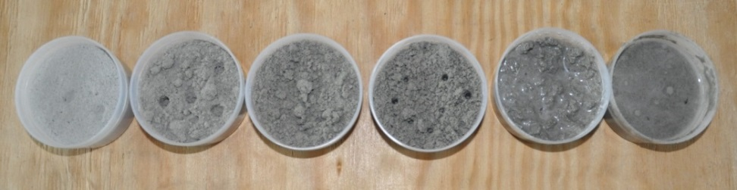
Figure 1: Six frozen samples of LHS with increasing volumes of water added. Each container has a diameter of 7.2cm and a height of 3.3cm
Volume of Water (ml) | Water Mass % | Observations
0 (dry) | 0.2 | Extremely soft, easy penetration
6 | 4.6 | Small clumps, fairly easy penetration
12 | 9.0 | Small clumps, very difficult to penetrate to the bottom
18 | 12.8 | Small clumps, unable to penetrate further than a few mm
24 | 17.3 | One solid, lumpy piece, unable to penetrate
30 | 20.3 | One solid, smooth piece, unable to penetrate
Table 1: Observations made when testing the hardness of LHS samples with different water mass percentages
These observations show that penetration becomes increasingly difficult the more water is added. Since the 24ml and the 30ml frozen samples were clearly cohesive and behaved like a single solid body, we considered them as most likely water-saturated. This was confirmed by thawing the samples, after which a very thin surface layer of liquid water could be seen on top of the 24ml sample, and a much thicker layer atop the 30ml sample. Moreover, the thawed samples had a mud-like consistence, with water draining as they were handled (Brouwer et al, 1985). As this was not the case for the 18ml sample, these facts indicate that saturation of the LHS likely occurs at a water mass content between 13% and 17%. These observations also indicate that the frozen regolith experiences a rapid change from soft to very hard when the water mass is in the range of 5% - 9%, which is examined in further detail in Section 4.

3. Simulant Preparation Procedures

The first step on the way to producing a suitable lunar icy regolith simulant is to define a suitable preparation method with reproducible results. Therefore a preparation procedure has been developed through which a controlled volume of water is added to the regolith simulant under ambient conditions. The wetted sample created would then be frozen, producing an icy lunar regolith simulant. The procedure will allow the production, within a reasonable time scale, of samples with a size and mass large enough for testing sampling devices such as L-GRASP in the laboratory under cryo-vacuum conditions. By varying the basic non-volatile constituents, the developed procedures can be useful not only for the lunar regolith, but also for other planetary surface materials, such as the ice-containing near-surface soils on Mars.
In order to provide the most benefit, the preparation procedure must be capable of producing icy LHS with water contents ranging from dry to saturated, with a targeted water mass content of 13%. Alongside the LHS, two other materials have been used as simulants to provide comparisons where necessary. One is the JSC-1A lunar analogue which, although not suitable for mimicking the polar regions, due to its common usage and established characteristics, can be used as a comparison simulant. The other material is a well characterized fine grained quartz sand, Schwarzl UK4, selected due to its easy availability in large quantities. This has also been used in a previous study as a substitute for the JSC-1 Mars material, and has a grain size distribution in the range of 0.1 - 1mm (Zöhrer and Kargl, 2005).
This section describes several attempts to define a suitable experimental method for the production of an icy regolith sample, finishing with a description of the method believed to work best for the purposes described above.

3.1 Initial Procedures

Initially, two preparation procedures were considered, with the aim of wetting the sample with water vapour in notably different ways. The first is to introduce vapour produced by a water disperser to the dry simulant via a tube. In the second, the dry sample is placed in a cooking pot, with water boiled below it. For each, the sample is held in a steel skeleton cage consisting of several equidistant rings with a 7.5cm radius and a 16cm height, as shown in Figure 2. A semi-permeable fleece covered the inner surface of the cage, holding the simulant in place while at the same time allowing diffusion of the water vapour.

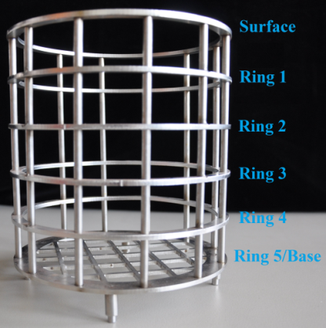
Figure 2: Picture of the sample cage and its rings
3.1.1 Water Disperser into Vacuum Chamber

The first procedure attempted was a design using a water disperser as shown in Figure 3 (a). This would produce finely-dispersed water droplets, which are fed via a feed-through tube into a vacuum chamber (Figure 3 (b)). The vapour flow was split inside the chamber and connected to the top and base of another closed container (Figure 3 (c)) placed inside the chamber. Within this closed container is the sample cage (Figure 3 (d)), with the simulant filled up to Ring 1. This container was encircled by copper tubing, which could be connected to a cooling circuit outside the vacuum chamber.
The original idea behind the design of this set-up was that it would have offered the possibility of establishing lunar conditions for the wetted sample after completion of the wetting phase, by creating a cryo-vacuum environment whilst simultaneously cooling the sample. However, the experiments performed here attempted only to create a wetted sample in ambient conditions, and as such neither the vacuum nor the cooling systems were used.

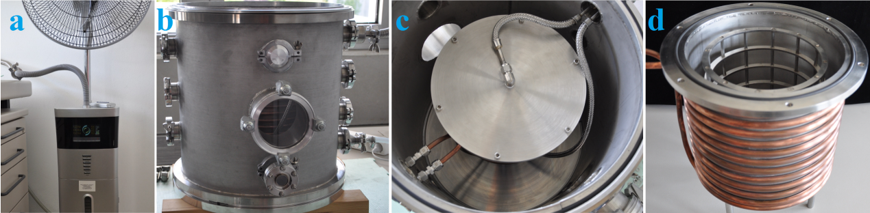
Figure 3: (a) Photograph of the water disperser and tube through which the water vapour flows used for the Water Disperser into Vacuum Chamber procedure, (b) the vacuum chamber, (c) the container placed in the vacuum chamber, with the lid attached and the water disperser tubes fixed on the lid and container base, and (d) the sample cage held inside the container, encircled by the copper cooling tube
Three experiments of 15 - 20 hours were performed using this procedure, however little to no wetting of the simulant was observed. This was due to the water vapour tubes becoming blocked after some time at the vacuum inlet, where the single tube is split into two. At this point, the cross-sectional area of the tube is much smaller than the rest of the tube, as can be seen in Figure 3 (c). Water droplets that had formed here eventually blocked the vapour flow, stopping it from reaching the simulant.

3.1.2 Hot Water Vapour

In the second procedure, a cooking pot was filled with water to a depth of 3cm. The sample cage, filled to Ring 1, was placed on supports inside the pot, so that the base of the cage was held just above the water’s surface, as seen in Figure 4. A lid, with a small hole to allow steam to escape and avoid pressure build-up, was placed over the top of the pot, which was positioned on a heating plate. The water was then boiled for three hours.

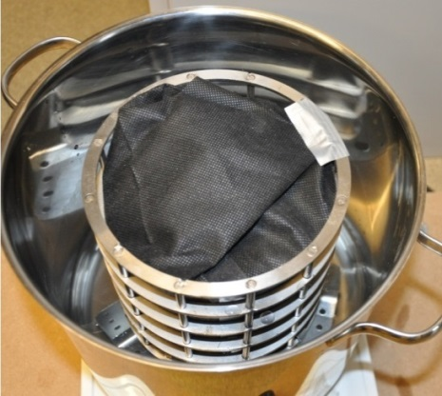
Figure 4: The set-up for the Hot Water Vapour procedure, excluding the lid. The covered sample cage is placed on supports in the cooking pot
After each experiment, two samples were taken from the surface; one from the centre and one from near the boundary. Pairs of samples were then taken at depths corresponding to just above each ring on the cage, as shown in Figure 2, and a final pair at the very base of the simulant. The samples' water mass contents were measured using the moisture analysis scale, with the results given in Figure 5. After this, the LHS sample was mixed and refilled in the sample cage to create a homogeneous sample. Water content measurements were again taken along the centreline from the surface to base. These values are denoted as the “Mixed” values given in Figure 5.

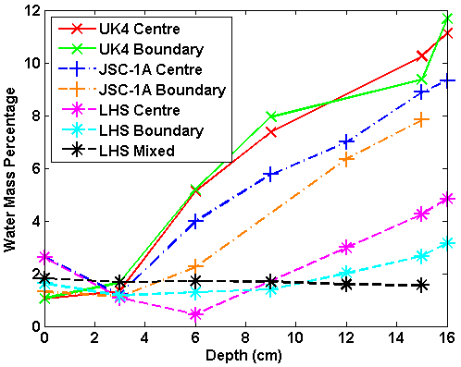
Figure 5: Graph of the water mass percentage values for the Hot Water Vapour experiments. The depth corresponds to the point at which the sample was taken, from the surface (0cm), to each ring (3 - 15cm) and the base (16cm)
The results from the experiments show that this method is fairly effective at wetting the UK4 and JSC-1A simulants, and that there is a clear relationship between water content and sample depth. It can also be seen that the LHS absorbs notably less water vapour than the other sample materials in this set-up. The centre and boundary measurements are fairly similar, with the centre values tending to be slightly larger. As expected, the water content measurements in the mixed LHS sample are roughly equal. However, it can be clearly seen that this method was not able to produce LHS nearing saturation, with the highest water mass value seen being ~5%. As a result, neither of the two methods discussed here can be considered to be suitable.
3.2 Improved Procedures

Although the initial procedures were not able to produce the required results, it was believed that, by making modifications to the set-ups, the distribution of the water into the regolith simulants could be significantly improved.

3.2.1 Pressurized Hot Water Vapour

The third series of experiments evolved the Hot Water Vapour procedure by replacing the cooking pot with a WMF pressure cooking pot, allowing higher vapour pressure inside the pot during the experiment. Due to the smaller size of the pressure cooking pot, a smaller sample cage with a 5.5cm radius and a 12cm height had to be used, consisting of a thin steel container with holes interspersed throughout, as illustrated in Figure 6 (a). The simulant was filled to the brim, giving an approximate volume of 1.14 x 10⁻³m³. The set-up is the same as that for the Hot Water Vapour, as shown in Figure 6 (b), with the water being boiled for three hours. Again all three simulants were used, with the UK4 being used twice, and each wetted sample was mixed.

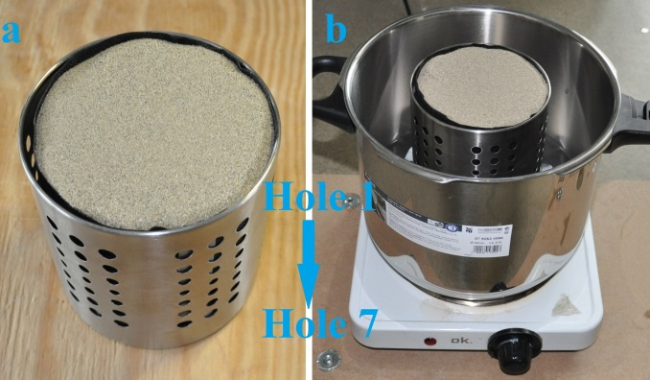
Figure 6: (a) The smaller sample cage, with the rows of holes labelled and (b) the set-up for the Pressurized Hot Water Vapour procedure, excluding the lid. The cage is again placed on supports above the water in the pot
After the experiment, the pot was allowed to depressurise for 20 minutes (75 minutes in the second UK4 experiment), by letting the steam slowly escape from the pot, before being opened. Samples were taken from the centre and near the outer boundary, and this time at depths corresponding to the surface, the cage’s 1st, 3rd, 5th and 7th holes, and the cage base. Measurements were taken in the same way as described in Section 3.1.2, and the results are given in Figure 7.

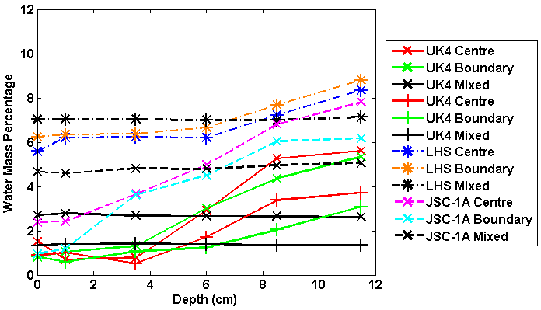
Figure 7: Graph of the water mass percentage values for the Pressurized Hot Water Vapour experiments
It was expected that, as the pressure cooking pot would hold more water vapour inside with the simulant, the amount of water having diffused into the sample would increase. However, when compared with the results given in Figure 5, it can be seen that the JSC-1A water content values with depths are broadly similar, while the UK4 values are considerably lower. The exceptions are the LHS values, exhibiting much higher values at and near the surface than any other experiment performed. The LHS water values continued to increase with depth, albeit at a gentler rate than before, resulting in a mixed sample with a much larger water mass of ~7% which, although still not achieving the target of 13%, is a considerable improvement. Additionally, the changes in the results seen for the UK4 and LHS from the Hot Water Vapour procedure suggest that water absorption by the simulants is very dependent on technique and conditions.

3.2.2 Open Water Disperser

This set-up was designed as a simplified version of the Water Disperser into Vacuum Chamber. This attempted to solve the issues caused by the blockage of the vapour tubes. Here, only the original sample cage is used, with a lid made using the semi-permeable fleece. The vapour is fed directly from the water disperser to the simulant via the disperser tube, which is inserted into a hole in the lid and held in place, as can be seen in Figure 8. The single tube allows for a large and consistent cross-sectional area, with no bottlenecks that could result in blockages.

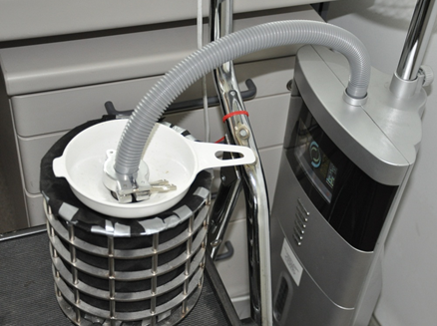
Figure 8: The set-up of the Open Water Disperser procedure. The vapour tube is connected directly from the disperser to the sample cage
The first two experiments with this procedure, using the UK4 sand and LHS, respectively, involved filling the cage with a layer of simulant up to Ring 4. This was wetted for one hour, before another layer was added, filling the cage to Ring 3 and subsequently wetted again for one hour. This was repeated one more time, filling the cage up to Ring 2. For the third experiment, Exp. 3, the cage was filled with LHS to Ring 2 from the beginning, and the simulant was wetted uninterrupted for three hours. Samples to be measured were then taken from depths corresponding to each ring and the base, after which the simulants were mixed and further samples taken. The results of these experiments are given in Figure 9.

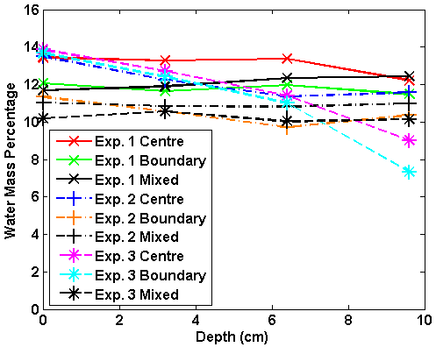
Figure 9: Graph of the water mass percentages for the Open Water Disperser procedure. The points correspond to the surface at Ring 2 (0cm) and Rings 3, 4 and 5 (3 – 9cm)
The results indicate that, even without mixing, the method of intermittently adding layers is capable of producing a very high and fairly homogeneous water content nearing saturation. Using a single layer also provides good results, giving similarly high mixed values, though there is a noticeable decrease in water content with depth. For this method, some small regions at the boundary of the base were noticeably drier than the surrounding simulant, having a water mass of only 4.5%. This suggests a fairly rapid change between wetted and dry simulant, and that while the vast majority of the simulant had been wetted, those particular regions had not yet been reached by the water diffusion front. As such, it can be proposed that the time of three hours given for this experiment is the minimum required to sufficiently wet the whole volume of the sample. The water mass values given for these experiments are consistently above 10%, making this technique by far the most effective for producing samples close to saturation.

3.2.3 Control of the Water Content

Given the success of the Open Water Disperser procedure, three additional tests were performed to examine how water mass content would change with altering vapour flow conditions, using the method of filling a layer of LHS up to Ring 2. The fourth experiment used a tube with a 6mm radius, compared to the 9mm radius of the original tube. The fifth experiment halved the vapour flow by using a tube splitter to allow vapour to flow through two tubes, with only one of these connected to the sample. The sixth experiment used the original 9mm tube, and a reduced experiment time of 1.5 hours. The results of these tests are given in Figure 10, and should be used in comparison with those given for experiment three as shown in Figure 9.

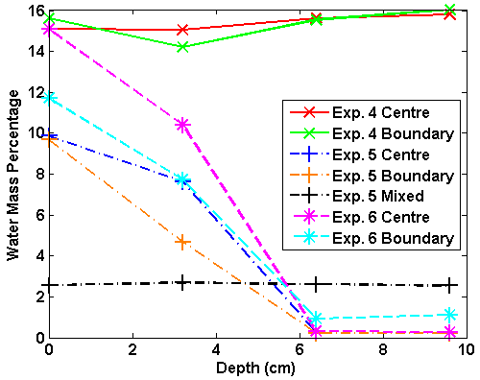
Figure 10: Graph of the water mass percentages for the second series of experiments using the Open Water Disperser procedure.
The results of Exp. 4 indicate that the LHS is wetted even more effectively and consistently with a smaller vapour tube. This could be due to the smaller cross-sectional area of the tube creating a faster vapour flow, given that the volume of water used for the experiments was constant. As a consequence, the water penetrates deeper and faster into the simulant, and less vapour is able to escape.
Exp. 5 and Exp. 6 both show a rapid decrease in water mass content, with the LHS becoming completely dry approximately halfway down. By halving the total vapour flow or time taken, only the upper half of the LHS sample is wetted. This is consistent with the observations of Exp. 3, which suggested that three hours of full vapour flow was the minimum required to fully wet the simulant. As a result, it will be possible to control the degree of saturation of the simulant by adapting the sample size, the time required and the vapour flow conditions.
A final test examined the effects of compacting the simulant, and used the same set-up as Exp. 3. The sample cage was subjected to shaking and hammer shocks while the simulant was poured into it. The water mass content of the compacted regolith, as given in Table 2, is fairly similar for rings two and three when compared to Exp. 3. However the water content decreases considerably, with the bottom 1cm being dry. This indicates that the increased compaction makes it more difficult for the water to diffuse through the simulant and as such, compaction must also be taken into account alongside the other variables previously mentioned.

Depth (cm) | 0 | 3.2 | 6.4 | 9.6
Centre | 12.0 | 10.4 | 7.3 | 0.3
Outside | 11.1 | 9.7 | 7.0 | 1.4
Mixed | 7.5 | - | 7.3 | -
Table 2: Water mass percentages for the LHS compaction experiment. The depth values are the same as those used in the previous Open Water Disperser experiments
The experiments performed here have demonstrated that the Open Water Disperser procedure is a technique capable of fulfilling the aim of producing lunar regolith simulants with a water content nearing saturation. It has also been demonstrated how the water content of the simulant can be controlled by altering the set-up of the procedure. Using this preparation procedure, simulants can be wetted under controlled conditions, producing samples with a pre-determined water content, after which the sample can be frozen, producing an icy regolith simulant that may be used for the testing of instruments under the required conditions.

4. Penetration Resistance and Compression Tests

With a suitable preparation procedure for producing icy regolith simulants established, it was now possible to begin the investigation into the properties of icy LHS under different degrees of saturation. This involves the first characterisation of the penetration resistances and compression strengths of an LHS sample with different water contents. The penetration profile of the LHS samples was measured to determine how the resistance changes with water content, depth and position in the sample. This will be used to provide greater detail and quantitative data for the qualitative observations reported in Section 2. The uniaxial compression tests will complement these results, determining the strength of the LHS and providing a comparison with the UK4 sand.
For these experiments, the water mass content of the samples to be tested was determined beforehand. An LHS sample with the maximum required water mass was created using the Open Water Disperser procedure, which was then mixed to create a homogeneous mixture and frozen overnight in a deep freezer at -20°C, after which the experiments were performed. After the experiment, the sample was dried at room temperature for a day or so and refrozen for the next test. This procedure was repeated several times, thus reducing the water content step by step, until the whole water mass content had evaporated.

4.1 Penetration Resistance Tests

As discussed in Section 2, the LHS appears to undergo a rapid change from soft to hard when the water mass increases from 5 to 9%. To examine this in greater detail, the penetration resistance profile of the LHS with water contents within this range was determined. The icy LHS used was that prepared in the compaction experiment described in Section 3.2.3, as this produced a mixed sample with a water content of ~7.4%. The penetration resistance was measured with a handheld FieldScoutSC9000 penetrometer, which has a conical tip with a diameter of 1.27cm and a full opening angle of 28°. The penetrometer was gently pushed into the simulant, as shown in Figure 11, and recorded the resistance experienced when pushed to a particular depth. To allow a full examination of the changes in strength across the entire sample, the differences in strength seen between the sample centre and boundary were also measured. As such, a measurement was taken first from the sample’s centre, and a number of subsequent measurements were made at various points near the boundary.

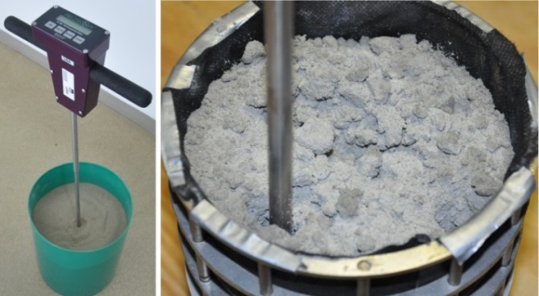
Figure 11: Picture of the FieldScoutSC9000 penetrometer, and a measurement taken at the boundary of the frozen LHS sample
A summary of the penetration tests is given in Table 3, with greater detail provided in Figure 12. It should be noted that, as these tests were performed with a handheld penetrometer, there will be inaccuracies caused by uneven penetration, and as such the results given should be considered as guidelines rather than as precise values. Also, after the first penetration through the centre, the sample will be disturbed and partially broken, potentially influencing the results of the following boundary measurements.

Water Mass % | Penetration resistance determined with FieldscoutSC9000
3 - 4 | Max penetration resistance about 1 MPa in the lower part of the sample, with the upper part being very soft, similar to dry powder
4 - 5 | Max penetration resistance about 3 MPa, but softer in the upper 5 – 6cm of the sample
7 - 8 | Max penetration resistance >3 MPa, hard over the whole depth range
Table 3: Summary of the results and observations made using the penetrometer
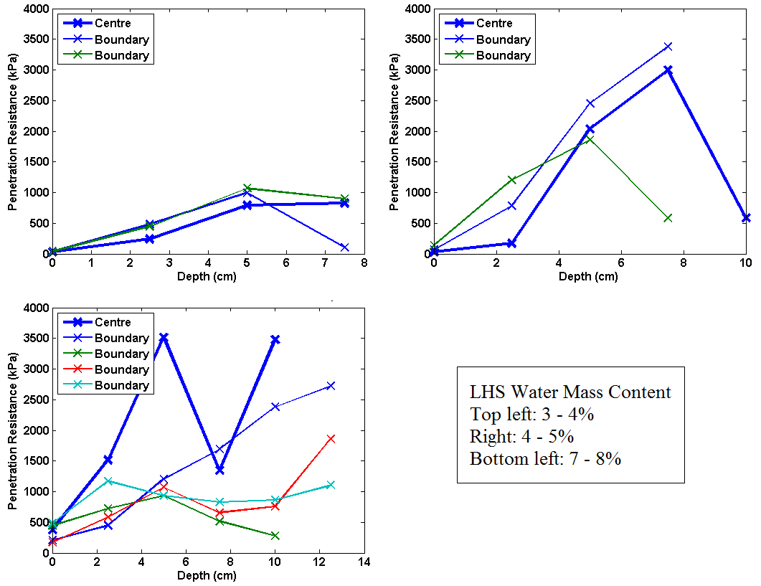
Figure 12: Results of the penetration tests of the frozen LHS sample with different water contents, measuring the resistance experienced by the penetrometer at incremental depths in the sample
These results support the observations given in Table 1, with a very clear decrease in penetration resistance as the water mass percentage decreases. The curves tend to show oscillation at some points, an expected phenomenon due to the alternating phases between elastic deformation and breakage of the solid material when a certain limit is exceeded. As noted in Table 3, the upper 5cm of the 4 – 5% sample was rather soft and easy to penetrate, but the lower half was much more difficult to penetrate. This is confirmed by the results seen in Figure 12, with the top 3cm having very low strength, whereas the measurements below this were similar to those found for the 7 – 8% sample. Even the 3 – 4% sample, which could be penetrated down to the bottom, showed a detectable strength increase below the top 3cm. As such, this suggests that the frozen LHS experiences a sharp change in penetration resistance when the water mass content is around 5 ± 1%. Additionally, the central penetration resistance of the 7 – 8% sample was much larger than the boundary values, whereas for the other two samples the boundary resistance was the slightly larger value. The sharp increase in central penetration resistance compared to that of the boundary resistance of the 7 – 8% sample may be a result of the simulant’s transition from soft to hard.
The results seen here show that there is a critical point at ~5% water mass where the penetration resistance increases dramatically. As at present there exists no data that could accurately determine the water mass content of the polar regolith, instrumentation to be used in the polar regions may encounter low or high resistance icy regolith. Until more detailed characterisation of the icy lunar regolith is available, instrument design will need to take into account the resistance seen with the higher water content.

4.2 Uniaxial Compression Tests

Supplementary to the cone penetration tests, standard uniaxial compression tests for the icy LHS and UK4 sand have been performed at the Geotechnical Laboratory of the Institute for Soil Mechanics and Foundation Engineering at Graz University of Technology.
For these experiments, three LHS samples with 3%, 6% and 12% water content respectively were created. Each was mixed to produce a high degree of homogeneity, before being filled into cylindrical containers of 7cm diameter and 14cm height. The walls of the containers consist of three separate segments that can be taken apart and removed. Once the samples’ densities were determined, they were frozen and kept for several days in a -20°C environment, producing consolidated cylinders of icy simulant with densities of 1550kgm⁻³.
The experimental set-up for the uniaxial compression tests is shown in Figure 13 (a). The sample is placed on the table, at which point the segments of the container are removed before being confined, though not compressed, by a cylindrical lid on the top. By doing this, the cylinder is confined only by the lid and the table. The sample is then squeezed between the two confinements by a slow upward motion of the table while the lid remains stationary. The axial resistance force of the sample against this constant motion is normalised to a pressure value by dividing the force by the sample’s cross sectional area. The deformation of the sample as the table moves upwards is recorded as the percentage change in axial height of the sample compared to its original height.
The test is stopped sometime after the maximal axial stress has been reached. Beyond this point the sample starts to fail mechanically, typically by forming crevasses which propagate from the upper or lower edge of the sample towards its interior. This can be seen in the base of the sample in Figure 13 (b). After this point, the sample begins to crumble and the stress begins to decrease. The uniaxial compression strength of the material is defined as the maximum compressive stress reached during a test run.

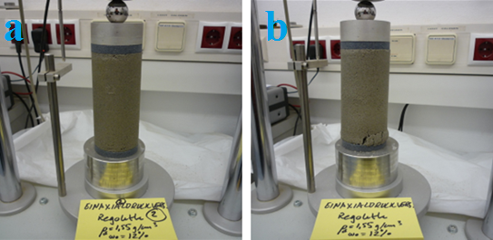
Figure 13: (a) Experimental set-up for the uniaxial compression tests, with the frozen regolith simulant held in place between the table and cylindrical lid, (b) the sample has begun to fail, as seen by the cracks that have formed at the base
Two tests were performed with each of the three frozen LHS samples. The results of these tests are presented as the coloured curves in Figure 14. The averages of each pair of tests were derived and are shown in the graph as the black lines. The maximum compression strengths of the average curves are also displayed. The graph shows how, as the sample is squeezed between the two confinements and the deformation increases, the uniaxial stress exerted by the sample along the cylindrical axis continuously increases. As the sample reaches its maximum compression strength, the increase in strength with deformation decreases, squeezing the sample until a point is reached in which the sample begins to fail mechanically. Here, the sample begins to crack, and the mechanical strength begins rapidly decreasing.

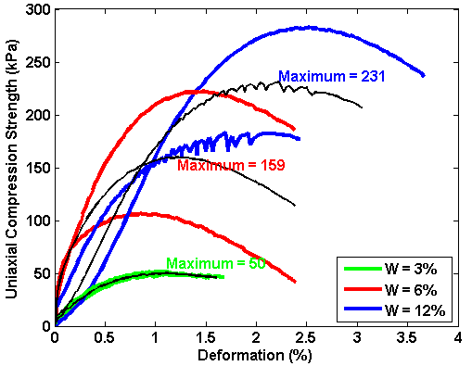
Figure 14: Graph of the uniaxial compression strength with deformation of the LHS with three water contents. The results from the tests are the coloured curves, and the averages for each water content are given by the black curves
It can be seen that the maximum compression strength of the LHS and the degree of deformation that occurs in the sample before the maximum strength is reached increases with water content, although it must be noted that there is a significant variation between the two tests for the 6% and 12% samples, with standard deviations of 58kPa and 49kPa respectively.
For comparison, uniaxial compression tests were also made with frozen UK4 sand with the same water mass values, in order to determine if this standard material behaves differently from the frozen LHS in terms of resistance against uniaxial compression. For these tests, a loose and a compacted material, with dry densities of 1400kgm⁻³ and 1700kgm⁻³ respectively, were used. As with the LHS, two tests were performed with each sample. The maximum compression strengths are presented in as the coloured data points, with the averages given as the black points on the corresponding lines.

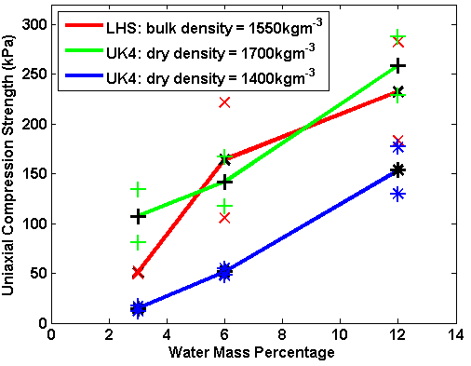
Figure 15: Graph of the maximum uniaxial compression strengths for the frozen simulants. The results from the tests are given as the coloured data points, and the averages for each simulant given as the black points on the corresponding curves
It can be seen that the uniaxial compressive strength of the frozen UK4 samples appears to depend both on dry density and water content. Whilst the strength of the frozen UK4 sands appears to increase linearly with water mass content, the frozen LHS seems to exhibit a more nonlinear behaviour, with the strength increase slowing down as the water mass approaches 12%. This may indicate that the uniaxial strength approaches a constant level (for a given temperature) as the water content approaches saturation.
Comparing the strength values obtained from the uniaxial compression tests with those estimated from the cone penetrometer measurements show that the cone penetrometer values are typically several times higher than the values obtained from the standard uniaxial compression test. This is to be expected, since in the uniaxial tests there is no side resistance, while in the cone penetration test the penetration force has to overcome the resistance exerted by the material surrounding the conical tip as well as the friction force along the shaft.

5. Conclusions

This paper has presented the first examination of the properties of simulants that mimic the regolith expected to be found in the lunar polar regions. A number of experiments were performed using the NU-LHT-2M lunar highland simulant to determine the changes in penetration resistance and uniaxial compression strength with varying water mass contents. Additionally, a number of preparation procedures were tested, with the aim of creating a procedure that could potentially be used as a standard procedure for producing icy regolith simulants. The main findings can be summarized as follows.
The lunar highland simulant was determined to have a saturation point around 13 – 17% water mass. Cone penetration tests have shown how the behaviour of the wetted and frozen LHS changes with increasing water content. A sharp increase in penetration resistance occurs when the simulant has a water content in the range of 5 ± 1% by mass. At this point, the penetration resistance of the simulant increases sharply after a depth of a few centimetres. Below this value, the simulant has low resistance throughout, and above, the samples became extremely difficult to penetrate. The compression strength of the LHS was also shown to increase with water content.
The changes in penetration resistance and strength with water content show how important it is to characterise the properties of icy lunar polar regoliths. As such, further data will need to be obtained which provides greater understanding of the extent and distribution of the water content of the polar regolith. While the experimental results reported here provide a first step towards the development and understanding of icy polar simulants suitable for instrumentation testing, further experiments should be performed to provide greater detail of the physical and thermal properties of icy highland simulants. Instruments such as L-GRASP that are required to penetrate the surface must be designed in such a way that they are able to overcome the strength of the icy regolith expected to be encountered.
Finally, the testing of a number of preparation procedures has demonstrated a suitable technique for producing icy LHS, with changes to the set-up able to produce simulants with controlled water contents from dry to saturated. It is envisioned that this technique could be further developed into a standardised procedure for which any icy regolith simulant could be produced for instrumentation testing.

Acknowledgements

The author would like to thank OHB Systems AG for providing the funding for the PhD to which this research shall contribute to, and to the Austrian Academy of Sciences and Graz University for their support and providing the facilities and equipment.

References

Battler, M. & Spray, J., 2009. “The Shawmere anothosite and OB-1 as lunar highland regolith simulants.” Planetary and Space Science 57, 2128-2131.
Brouwer, C., Goffeau, A. & Heibloem, M., 1985. “Irrigation Water Management: Training Manual No. 1 – Introduction to Irrigation.” Food and Agriculture Organization of the United Nations, Rome, Italy.
Colaprete, A., Schultz, P., Heldmann, J., Wooden, D., Shirley, M., Ennico, K., Hermalyn, B., Marshall, W., Ricco, A., Elphic, R., Goldstein, D., Summy, D., Bart, G., Asphaug, E., Korycansky, D., Landis, D. & Sollitt, L., 2010. “Detection of Water in the LCROSS Ejecta Plume.” Science 330, 463-467.
Cooper, B., Paz, A. & Smith, M., 2011. “Preparation and Testing of Ice-Enriched Lunar Regolith Simulant for RESOLVE OVEN.” In Planetary and Terrestrial Mining Sciences Symposium, Ottawa, Canada.
Fisackerly, R., Carpenter, J., Houdou, B., Visentin, G., Savoia, M., Rizzi, F., Magnani, P., Barber, S., Reiss, P. & Richter, L., 2014. “Accessing, Drilling and Operating at the Lunar South Pole: Status of European Plans and Activities.” In Earth and Space Science 2014: Engineering for Extreme Environments, St. Louis, USA.
Gertsch, L., Gustafon, R. & Gertsch, R., 2006. “Effect of Water Ice Content on Excavatability of Lunar Regolith.” In Space Technology and Applications International Forum 813, 1093-1100, Melville, USA.
Hegde, U., Balasubramaniam, R. & Gokoglu, S., 2012. “Analysis of Water Extraction From Lunar Regolith.” In 50th Aerospace Science Conference, Nashville, USA.
Mantovani, J., Swanger, A., Townsend III, I., Sibille, L. & Galloway, G., 2014. “Characterizing the Physical and Thermal Properties of Planetary Regolith at Low Temperatures.” In ASCE International Conference on Engineering, Science, Construction and Operations in Challenging Environments, St. Louis, USA.
Metzger, P., Galloway, G., Mantovani, J., Zacny, K. & Craft, J., 2011. “Low Force Icy Regolith Penetration Technology.” NASA/TM-2011-216302, NASA Centre for Aerospace Information, Hanover, USA.
Mitrofanov, I., Sanin, A., Boynton, W., Chine, G., Garvin, J., Golovin, D., Evans, L., Harshman, K., Kozyrev, A., Litvak, M., Malakhov, A., Mazarico, E., McClanahan, T., Milikh, G., Mokrousov, M., Nandikotkur, G., Neumann, G., Nuzhdin, I., Sagdeev, R., Shevchenko, V., Shvetsov, V., Smith, D., Starr, R., Tretyakov, V., Trombka, J., Usikov, D., Varenikov, A., Vostrukhin, A. & Zuber, M., 2010. “Hydrogen Mapping of the Lunar South Pole Using the LRO Neutron Detector Experiment LEND.” Science 330, 483-486.
Oravec, H., Zeng, V. & Asnani, V., 2010. “Design and characterization of GRC-1: A soil for lunar terramechanics testing in Earth-ambient conditions.” Journal of Terramechanics 47, 361-377.
Orbitec. “Characterization Summary of JSC-1A Bulk Lunar Mare Regolith Simulant.” 2007. http://www.orbitec.com/store/JSC-1A_Bulk_Data_Characterization.pdf.
Phebus, B., Johnson, A., Mar, B., Stone, B., Colaprete, A. & Iraci, L., 2011. “Water ice nucleation characteristics of JSC Mars-1 regolith simulant under simulated Martian atmospheric conditions.” Journal of Geophysical Research 116.
Richter, L., Hofmann, P., Mühlbauer, Q., Ng, T. C., Paul, R. & Schulte, W, 2013. “Technologies for Automated Sample Handling and Sample Distribution on Planetary Landing Missions.” In ASTRA 2013, Noordwijk, Netherlands, May.
Schrader, C., Rickman, D., Mclemore, C., Fikes, J., Stoeser, D., Wentworth, S. & McKay, D. “Lunar Regolith Characterization for Simulant Design and Evaluation Using Figure of Merit Algorithms.” Orlando, Florida, USA: 47th AIAA Aerospace Sciences Meeting, American Institute of Aeronautics and Astronautics, 2009.
Schrader, C., Rickman, D. McLemore, C. & Fikes, J., 2010. “Lunar Regolith Simulant User's Guide.” NASA/TM-2010-216446, NASA Centre for Aerospace Information, Hanover, USA.
Seiferlin, K., Ehrenfreund, P., Garry, J., Gunderson, K., Hütter, E., Kargl, G., Maturilli, A. & Merrison, J., 2008. “Simulating Martian regolith in the laboratory.” Planetary and Space Science 56, 2009-2025.
Siegler, M., Aharonson, O., Carey, E., Choukroun, M., Hudson, T., Schorghofer, N. & Xu, S, 2012. “Measurements of thermal properties of icy Mars regolith analogs.” Journal of Geophysical Research 117.
Stoeser, D., Wilson, S. & Rickman, D., 2010. “Design and Specifications for the Highland Regolith Prototype Simulants NU-LHT-1M and -2M.” NASA/TM-2010-216438, NASA Centre for Aerospace Information, Hanover, USA.
Taylor, L., 2010. “Status of Lunar Regolith Simulants and Demand for Apollo Lunar Samples.” Simulant Working Group of the Lunar Exploration Analysis Group and Curation and Analysis Planning Team for Extraterrestrial Materials.
Willman, B., Boles, W., McKay, D. & Allen, C., 1995. “Properties of Lunar Soil Simulant JSC-1.” Journal of Aerospace Engineering 8, 77-87.
Yonchun, Z., Shijie, W., Ziyuan, O., Yongliao, Z., Jianzhong, L., Chunlai, L., Xiongyao, L. & Junming, F., 2009. “CAS-1 lunar soil simulant.” Advamces in Space Research 43, 448-454.
Zöhrer, A. & Kargl, G. “Finite Element Modelling of Penetration Tests into Martian analogue Materials.” Anavyssos, Attica, Greece: 3rd International Workshop Planetary Probe, 2005.

