Enhancing the retrieval of stream surface temperature from Landsat data

Belén Martí-Cardona¹, Jordi Prats², Raquel Niclòs³
1. Dep. of Civil and Environmental Engineering, University of Surrey, 29AA03, Guildford, Surrey GU2 7XH, U.K.
b.marti-cardona@surrey.ac.uk (corresponding author)
2. UR RECOVER, Pôle AFB-Irstea hydroécologie plans d’eau, Irstea, 3275 Route de Cézanne, Aix-en-Provence 13182, France
3. Department of Earth Physics and Thermodynamics, Faculty of Physics, University of Valencia., 50 Dr. Moliner, E-46100, Burjassot, Spain

ABSTRACT
Thermal images of water bodies often show a radiance gradient perpendicular to the banks. This effect is frequently due to mixed land and water thermal pixels. In the case of the Landsat images, radiance mixing can also affect pure water pixels due the cubic convolution resampling of the native thermal measurements. Some authors recommended a general-purpose margin of two thermal pixels to the banks or a minimum river width of three pixels, to avoid near bank effects in water temperature retrievals. Given the relatively course spatial resolution of satellite thermal sensors, the three pixel margin severely restricts their application to temperature mapping in many rivers. This study proposes a new algorithm to enhance the retrieval of stream surface temperature using Landsat 8 thermal data, although it is also applicable to Landsat 7 and Landsat 5. The aim is not to perform a subpixel radiance unmixing but to refine the selection of unmixed, reliable pixels for temperature mapping. For this purpose, the spatial arrangement of native Landsat thermal pixels is approximated, and pure water pixels in the downscaled thermal band are selected accordingly. The least-favourable cubic convolution near-bank radiance mixing is simulated on image basis. Only pure thermal water pixels unaffected by the simulated worst-case resampling are selected. The algorithm allowed retrieving water surface temperature in reaches down to 120 m wide, clearly improving the existing three pixel, i.e. 300 m for Landsat 8, recommendation. The enhancing algorithm was applied to a reach in the Ebro River reach, Spain. It provided spatially distributed temperatures in narrow parts, upstream and downstream of a wide reservoir, offering new insight of the overall impact of the reservoir over the river thermal regime.

Key words: river surface temperature, Landsat 8 thermal band, thermal spatial resolution, cubic convolution resampling, thermal impact, Mequinenza Reservoir, Ebro River, thermal stratification.

- INTRODUCTION
Temperature is a primary indicator of water quality in rivers and lakes and has direct effects on the physiology and spatial distribution of aquatic biota (Shuter and Post, 1990; Torgersen et al., 1999; Yvon-Durocher et al., 2012; Parkinson et al., 2016). Recognizing the critical role of water temperature for the sustainability of freshwater ecosystems, the European Water Framework Directive and the US Environmental Protection Agency, among others, regulate its changes and call for appropriate monitoring.
Stream water temperature variations occur at different spatial scales, from the regional longitudinal gradients, to the local lateral and vertical ones (Ward, 1985; Cassie, 2006). At the regional scale, mean annual water temperature tends to increase with decreasing altitude (Ward, 1985; Cassie, 2006), although local processes can alter this general trend (Fullerton et al., 2015). At the local scale, lateral differences of up to several degrees can be caused by the existence of dead zones at the river margin, shading by banks and riparian vegetation, groundwater inflows, bed heat conduction, etc. (Webb et al., 2008). In addition, groundwater inflows and human impacts can create complex patterns of temperature variability, persisting over long distances (Lowney, 2000; Prats et al., 2012; Nichols et al., 2013). While large-scale patterns help explain the overall distribution of species and ecological behaviour of the river, small scale variability may create thermal refuges that allow the presence of fish species in areas otherwise inappropriate for their survival (Torgersen et al., 1999).
Spatial thermal patterns are difficult to capture by using on-site measurements because of their discrete character (Handcock et al., 2012). Instead, remote sensing enables the observation of instantaneous, spatially distributed temperatures over inland water bodies at the regional scale.
Numerous studies have used satellite imagery to identify thermal patterns in lakes and reservoirs (Steissberg et al., 2005; Marti-Cardona et al., 2008; Alcântara et al., 2010; Schneider and Hook, 2010; Prats et al., 2018). Yet, the use of spaceborne thermal data for stream temperature mapping has been severely limited by their coarse spatial resolution (Cherkauer et al., 2005; Handcock et al., 2006): most distributed thermal measurements over streams are obtained from airborne instruments (Torgersen et al., 2001; Cherkauer et al., 2005; Carbonneau and Piegay, 2012), while the use of satellite data have been restricted to wide rivers, such as: the Columbia River and the Yakima River in Washington State, U.S. (Cherkauer et al., 2005), the Danube River in Romania (Zoran, 2011), the Rhône River (Wawrzyniak et al., 2012) and the Loire River (Lalot et al., 2015) in France, the Ebro River (Marti-Cardona et al. 2016) and the Guadalquivir River (Díaz-Delgado et al., 2010) in Spain, or the Qingjiang River in China (Ling et al., 2017). Comprehensive reviews of river and stream thermal remote sensing can be found in Handcock et al. (2012) and Dugdale (2016).
A minimum river width of three pixels is recommended in the literature to reduce the effect of near-bank reflected radiance and retrieve reliable water surface temperatures (Cherkauer et al., 2005; Handcock et al., 2006; Wawrzyniak et al., 2012). Among publicly available satellite thermal data, ASTER/Terra and Landsat 5, Landsat 7 and Landsat 8 offer the highest spatial resolution, with native pixel spacing of 90 m, 120 m, 60 m and 100 m, respectively. The three pixel width requirement implies that they can only be used for temperature mapping in river reaches wider than 180 m to 360 m. Cherkauer et al. (2005) showed that only 6% of thermally impaired river reaches in the state of Washington could be monitored with these satellite capabilities.

Satellite remote sensing could be applied to the observation of narrower river reaches by using an unmixing algorithm. A substantial number of subpixel unmixing algorithms have been proposed to sharpen the spatial resolution of thermal images for land applications (Ha et al., 2013; Zhan et al., 2011), while few authors have attempted to sharpen the retrieval of stream temperatures. Gustafson et al. (2003), Teggi (2012), and Despini and Teggi (2013) developed unmixing algorithms which improved remarkably the resolution of fluvial temperatures obtained from ASTER data, although limited validation was provided. Sentlinger et al. (2008) proposed a methodology based on known vectorised water boundaries to downscale MODIS data from 1 km to 100 m resolution. However, land-water boundaries of rivers and reservoirs may vary rapidly due to water level changes and wind induced tilting of the surface, complicating the availability of accurate water boundaries (Ramos-Fuertes et al., 2014).
In the case of Landsat data, the spatial resolution limitation is aggravated by the fact that thermal bands are resampled by cubic convolution from their native resolution to 30 m pixel spacing for product distribution. The resampling introduces uncertainty on the purity of stream thermal pixels close to the banks. Unfortunately, the native resolution thermal data or the relative position between original and resampled thermal pixels are not made available (USGS EROS User Services, 2017), which impedes the application of existing sharpening algorithms. With the aim to determine pure water thermal pixels in Landsat 8 scenes, Marti-Cardona and Prats (2018) proposed a method based on a morphological erosion of the images’ water masks. This method was limited to parts of the river wider than 210 m to 300 m, despite Landsat 8’s thermal resolution being 100 m.
In this paper we improve the previous algorithm by estimating the near-bank radiance mixing caused by the cubic convolution resampling, which depends on the thermal contrast between water and land, and on the river geometry. Landsat 8 images of a 162 km–long reach in the Ebro River, Spain, encompassing the 90 km-long Mequinenza reservoir, were used. The resampling mixing effect was simulated on an image basis and the maximum error that could possibly be introduced by the resampling blurring was calculated. This simulation enabled a more informed rejection of likely mixed pixels and selection of reliable ones, and allowed to retrieve surface temperatures in river reaches down to 120 m wide.

- STUDY AREA
The study area encompasses 162 km of the lower Ebro River, in North East Spain, including the 90 km long Mequinenza reservoir, approximately 70 km of the upstream river reach and a 2 km-long river segment downstream of the Mequinenza dam (Fig. 1). The Ebro River is the second largest in the Iberian Peninsula by length and flow discharge. At Mequinenza, the Ebro surface catchment extent is of approximately 55 000 km², with an average annual precipitation and discharge of 561 mm and 291 m³ s⁻¹, respectively. The Ebro River joins the reservoir between distances 65 km and 90 km, depending on the water level. From distance 0 km to 55 km the river water surface width ranges between 90 and 200 m, the flowing water is normally well mixed and its temperature is uniform in depth (Roura Carol, 2004). Between distances 55 km and 65 km, the river width increases rapidly in the downstream direction from approximately 90 m to 330 m. In the 2 km downstream of the Mequinenza dam, at the bottom end of the study area, the river water surface is 170 m to 270 m wide.

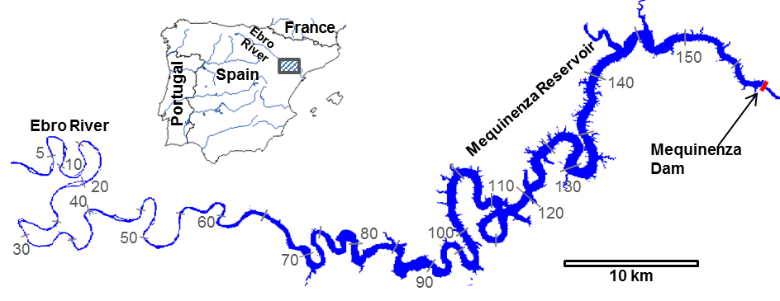
Fig. 1. Study area: Ebro river reach, including the Mequinenza reservoir. The distance coordinates used for the analysis of the results are indicated at 10 km intervals. The Mequinenza dam is located at the distance coordinate 158.1 km.

Mequinenza is a monomictic reservoir, meaning that its thermal behaviour undergoes two phases: a long stratification period, when the water temperature decreases in depth, and a short overturn or vertical mixing period (Roura Carol, 2004; Prats et al., 2011). The stratification begins towards the beginning of the spring, develops till August and often persists until late autumn. During normal operation, the impounded water is abstracted 5 m above the reservoir bottom at the Mequinenza dam and released downstream for hydroelectric power generation (Prats et al., 2011).
The annual surface temperature cycles for the impounded and flowing river water are clearly different (Martí-Cardona and Prats, 2018): the annual thermal amplitude is lower for the reservoir surface than for the river. Additionally, the reservoir surface cycles are delayed in the year with respect to the river ones, due to the larger thermal inertia of the impoundment. As a consequence, in autumn, the inflowing Ebro water is colder than the reservoir surface. At the confluence, the colder and denser fluvial waters submerge under the reservoir surface and mix with the matching density layer.

3.METHODOLOGY
3.1 Experimental data
Satellite imagery
Six Landsat 8 cloud-free images of the Mequinenza reservoir acquired throughout the year 2016 were used in this study. An additional image acquired on 22 Jan. 2018, coinciding with a ground truth campaign, was used for validating the method results.
Landsat 8 carries two imaging sensors on board, the Operational Land Imager (OLI) and the Thermal Infrared Sensor (TIRS). OLI measures optical radiance at 30 m spatial resolution (Irons et al., 2012; Roy et al., 2014), while TIRS collects data in bands 10 and 11. Only band 10 was used in this study, since band 11 is affected by stray light effects and its use is discouraged until an adequate correction is developed (Barsi et al., 2014; U.S. Geological Survey, 2017c). TIRS data are acquired at 100 m spatial resolution and resampled to 30 m through cubic convolution for distribution, in order to match the optical bands’ grid spacing (U.S. Geological Survey, 2017a).
Landsat 8’s Collection-1 Tier-1 Level-1 products were downloaded from the Earth Explorer portal for path/row 199/031 and for the dates listed on Table 1. The corresponding surface reflectance products for the OLI bands (USGS, 2017b; Pahlevan et al., 2017) were obtained on-demand through the same portal. The TIRS band 10 was calibrated to radiance as indicated in USGS (2017a) and corrected for atmospheric effects following Barsi et al. (2003) and Barsi et al. (2005) to retrieve the water leaving thermal radiance. A water emissivity value of 0.991 was adopted for a relatively smooth reservoir surface and for Landsat 8 band 10.

Table 1. Cloud free Landsat 8 acquisitions over the Mequinenza reservoir used in this study
Acquisition dates
05 Mar. 2016
25 Jun. 2016
28 Aug. 2016
29 Sep. 2016
15 Oct. 2016
16 Nov. 2016
22 Jan. 2018

Field data
Ground truth data was collected on 22 January 2018 over a three hour period around the Landsat 8 overpass at 10:43 GMT. Surface leaving radiance and downwelling sky radiance were measured in six thermal bands (wavelengths 8-14 µm) at fifteen points along the river between distances 54 km and 64 km in Fig. 1. This reach is located right upstream of the Mequinenza reservoir tail. On the image date, the reach water surface was approximately 330 m wide at distance 64 km, and rapidly narrowed down to widths from 200 m to 90 m in the upstream direction. This reach allowed to test the performance of the proposed algorithm, whose aim is the retrieval of water temperature in streams of width from 100 m to 300 m, i.e. between 1 and 3 Landsat 8 native thermal pixels wide. Five additional temperatures were collected across the river at distance 64 km. All measurements were acquired with a hand-held Cimel Electronique multiband radiometer, model CE-312 (Sicard et al., 1999; Legrand et al., 2000), which was calibrated in the laboratory before the ground truthing campaign. To determine the absolute river surface temperatures, the downwelling sky radiance reflected by the water was subtracted from the surface leaving radiance. The river water emissivity at the CE-312 instrument bands was estimated following the method in Niclòs et al. (2018). The surface water temperature was then obtained by inverting Planck’s function as described in Niclòs et al. (2014). The temperatures adopted as ground truth were those derived for CE-312 band 3, because in this band the river emissivity values were highest, thus minimizing the propagation of possible uncertainties (Niclòs et al., 2018). A linear time correction was applied to the measured temperatures to account for the time difference between the measurement and the satellite overpass.
Other ancillary data collected for this study, which aided the atmospheric correction of the Landsat images and the interpretation of the remote sensing results, are: air temperature, relative humidity and atmospheric pressure recorded in 2016 at the Caspe meteorological station (coordinates E 752 052 m N 4 558 229 m, UTM30 ETRS89); daily reservoir surface elevation measured by the Confederación Hidrográfica del Ebro (Ebro River catchment authority, CHE) near the Mequinenza dam (coordinates E 773 866 m N 4 585 085 m, UTM30 ETRS89); daily river inflow into the impoundment and hourly discharge from the dam, also provided by CHE. The water surface elevation, inflows and outflows from Mequinenza reservoir throughout the year 2016 are represented in Fig. 2. The vertical lines indicate the dates of the 2016 Landsat 8 images used in this study.
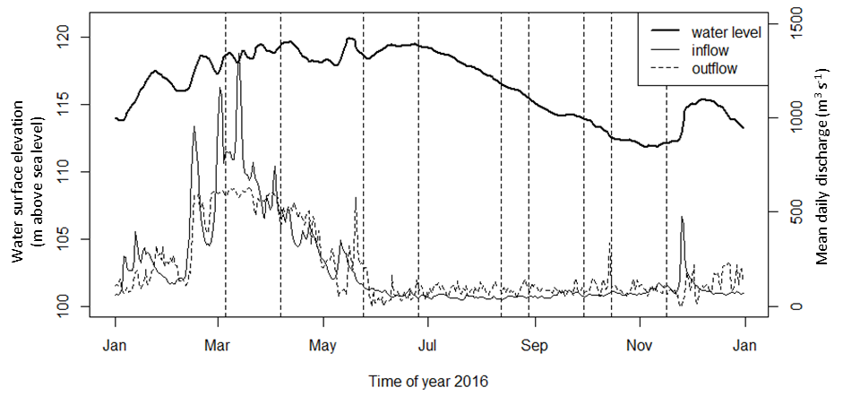
Fig. 2. Mean daily inflow and outflow discharge and water surface elevation in the Mequinenza reservoir in 2016. The vertical lines indicate the dates of the Landsat 8 acquisitions.

3.2 Mask of pure water pixels in optical bands
Pure water pixels were identified on Landsat optical bands using the Modified Normalised Difference Water Index (MNDWI; Xu, 2006). Xu (2006) reported accurate water extraction for MNDWI equal or higher than 0.0. In this study, a safer threshold of 0.05 was used to decrease the probability of selecting water pixels with some degree of emerging vegetation or near-bank elements. Since derived from Landsat 8’s green and SWIR bands, the pixels spacing of this mask is 30 m. The river longitudinal axis or centre line was manually digitised using the water mask from Nov. 2016, when the reservoir level was lowest, and then rasterised for its use in the following image processing steps. The Landsat 8 quality assurance band was used to mask out non-clear terrain pixels, i.e. pixels with likely presence of snow or ice, cloud or cloud shadow, radiometric saturation and terrain occlusion (Roy et al., 2002).

3.3 Retrieval of pure water pixels in the native thermal band
Landsat TIRS pixels are resampled from their 100 m native resolution to 30 m for distribution. Unfortunately, the USGS does not currently distribute the native resolution data and it is therefore not possible to ascertain the relative position between original and resampled TIRS pixels (USGS EROS User Services, 2017). In this study, with the aim to determine pure water pixels in the thermal band, the relative position between the 100 m Landsat 8’s thermal measurements and the 30 m distributed pixels was assumed. Based on the hypothesized position, 100 m TIRS pixels falling entirely within the water mask were determined. Then, only the downscaled 30 m pixels falling entirely within the pure 100 m ones were selected, and their thermal radiance along the river centre was plotted. Fig. 3 illustrates this procedure.
The procedure was repeated for different relative positions of native versus downscaled pixels: the assumed position was shifted in the lines and samples directions at 10 m intervals resulting in 100 possible relative arrangements, and 100 water leaving thermal radiance long profiles were obtained.
For each analysed image, all 100 profiles were remarkably coincident over the wide areas of the reservoir, where the relative displacement takes place over a fairly uniform surface without approaching the embankments. The effect of the assumptions on the relative position became apparent in reaches of width ranging from 100 m to 400 m, such as between distance coordinates 83 and 85 km in Fig. 4. For all the images, one to four profiles consistently showed lower thermal radiance than the rest in the narrow reaches indicating that they were obtained from pure water thermal pixels, and therefore that their associated native TIRS pixel position was approximately correct. Once the arrangement of the native TIRS pixels had been estimated, the downscaled ones falling within were selected to obtain a mask of pure water thermal 30 m pixels for each image.
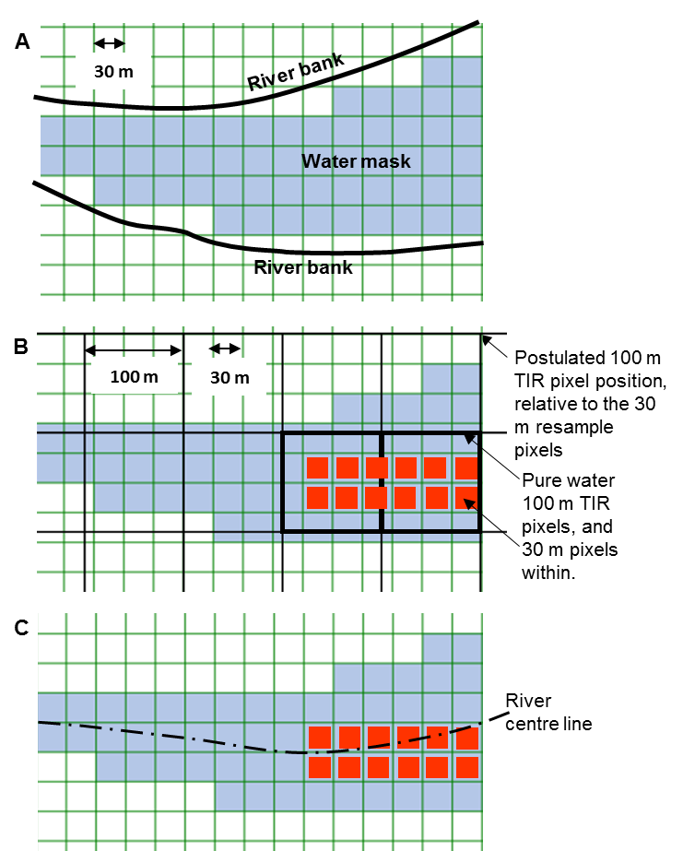
Fig. 3. Selection of pure thermal pixels for plotting the river thermal profile: a) a water mask is derived from Landsat 8’s 30 m optical bands; b) the position of the native 100 m TIRS pixels is assumed, the pure water 100 m pixels and the 30 m pixels within (in red) are selected accordingly ; c) The red 30 m pixels within a 3x3 neighbourhood of the river centre line are averaged to obtain the river longitudinal thermal profile

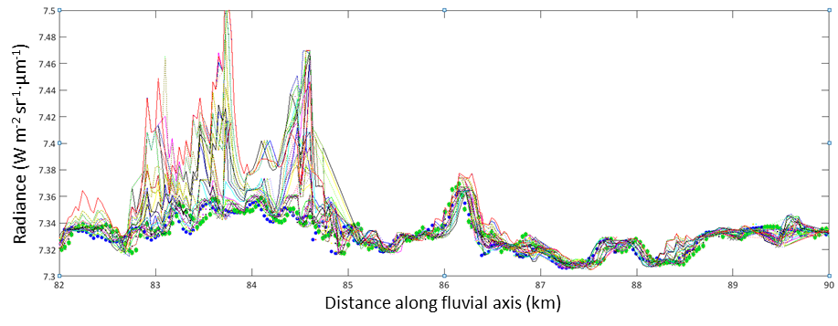
Fig. 4. Water-leaving radiance profiles for different assumed positions of the native TIRS pixels, in the Landsat 8 image from 5 Mar. 2016: the river surface width is clearly wider than 400 m downstream of coordinate 85 km; between 83 and 85 km the river width was between 300 m and 400 m on the image date. Blue and green dot profiles exhibit the lowest radiance, indicating that they were obtained from pure water thermal pixels

3.4 Look-up table for cubic convolution resampling error
The cubic convolution resampling interpolates a cubic polynomial function through the 16 pixel values whose centres are closest to the resampled one. Consequently, a resampled value will be influenced by land radiance if land pixels are present within its 16 closest neighbours. For Landsat 8 TIRS, a 16–pixel neighbourhood corresponds approximately to an area of 400 m x 400 m. The degree of land contamination will depend on the relative position of the land pixels in the neighbourhood, i.e. on the geometry of the water body surface, and on the ratio of land to water thermal radiance, notably variable between day and night images, and among seasons. Fig. 5 shows the near bank thermal radiance mixing in a reach of the study area. The radiance gradients orthogonal to the river banks are a consequence of mixed thermal pixels and convolution mixing. The blue-purple patches correspond to unmixed water thermal radiance. Their selection is the purpose of the method developed by this study.
The radiance mixing introduced by the convolution was simulated for different land to water relative radiances as follows: first, the 30 m water mask was resampled to a 10 m resolution grid. Water pixels were assigned value 1, while overland pixels were given value C representative of the land to water radiance ratio. An image was simulated by resampling the modified water mask to 100 m resolution using the boxcar or averaged window method. This simulation assumes the linear mixing of radiance (Asner et al., 1997). Cubic convolution was applied to resample again the latter image to 30 m resolution. The entire process was repeated for the contrast value C ranging from 0.8 to 1.2. The errors introduced by the cubic convolution, calculated as the ratio of the resampled to the original value, were compiled in a pixel-specific look-up table as a function of the land to water radiance contrast (Fig. 6).
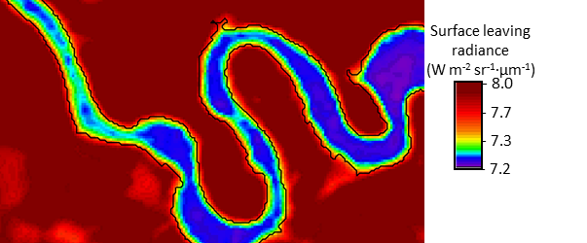
Fig. 5. Water leaving radiance in a reach of the Mequinenza reservoir, derived from Landsat 8´s band 10, acquired on 22 Jan. 2018. The black line indicates the water perimeter. Water-land radiance mixing is revealed by the thermal gradients perpendicular to the banks.

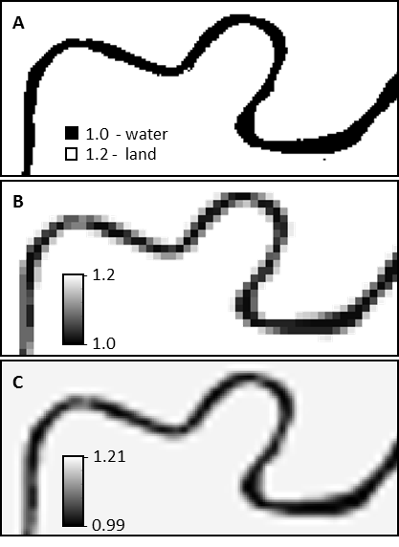 | A. 10 m water mask: water and land pixels are assigned values 1 and 1.2, respectively, to simulate a 1.2 relative radiance contrast.  B. Resampling of image A to 100 m by averaging pixel values. Image B simulates a 100 m spatial resolution image of A.  C. Cubic convolution resampling of image B to 30 m resolution. Water pixels’ values indicate the near bank radiance mixing due to poor thermal resolution and cubic convolution resampling, for a uniform relative radiance contrast of 1.2
Fig. 6. Per-pixel estimation of the radiance mixing caused by the cubic convolution for a given land to water radiance contrast.

3.5 Application of masks and look-up table to the Landsat 8 thermal band
The obtained masks of pure water thermal pixels and clear terrain pixels were applied to the 30 m Landsat 8 thermal band of the Mequinenza reservoir. A 13 x 13 moving window was then slid over the remaining river pixels. The moving window approximates the size of the 16-pixel neighbourhood used for the cubic convolution downscaling of the original 100 m resolution thermal image. Within the 13 x 13 pixel window, the maximum contrast between the centre pixel and the neighbouring non-water pixels in the thermal radiance band was determined. The pixel-specific look-up table was then used to determine an upper bound of the convolution error for each river pixel, based on the maximum radiance contrast in its neighbouring non-water pixels. Pixels whose thermal radiance was affected by a maximum relative convolution error greater than 1.005 or lower than 0.995 were also masked out. This threshold value is discussed in Section 4.1.
It is worth noting that maximum convolution error and thermal radiances showed a good correlation (Pearson’s coefficient of 0.778) substantiating the proposed method for selecting uncorrupted pixels.

Fig. 7 presents a flow chart of the processing steps, from the generation of the water mask (Section 3.2) to the selection of reliable pixels for temperature mapping (Section 3.5). The processing steps from the derivation of the clear terrain pixels mask (Section 3.2) to the generation of reliable thermal pixels mask (Section 3.5) were implemented in a Matlab code. The code took less than ten minutes to run in a 12 GB RAM personal computer, using a subset of the Landsat 8 scenes of approximately 2 400 x 800 pixels. The code required human intervention for the selection of the lowest thermal radiance profile on image basis. The river centre line was also manually digitized. Both manual steps should be relatively simple to automate.

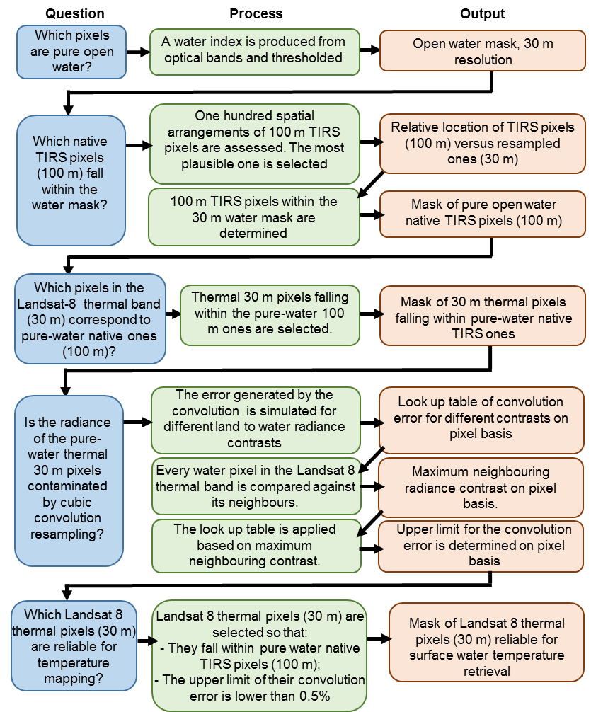
Fig. 7. Flow chart of the processing steps, from the generation of the water mask to the selection of reliable pixels for temperature mapping.

3.6 Longitudinal temperature profile
Once pixels reliable for temperature mapping were selected, their water leaving radiance along the river centre line was retrieved for each date. The radiance of the pixel exactly on the centre line was averaged with the river-mask pixels in a 3x3 neighbourhood. The radiance to temperature conversion was made by applying the Landsat specific estimate of Planck’s law given by Eq. (1), where T (ºC) is the surface temperature, L_{w} (W m⁻²·sr⁻¹·μm⁻¹) is the surface-leaving radiance and k₁ and k₂ are calibration constants included in the image metadata file with value 774.8853 W m⁻²·sr⁻¹·μm⁻¹ and 1321.0789 K, respectively (Landsat 8 Science Data Users Handbook, 2015).
$T=\frac{k_{2}}{Ln\left(\frac{k_{1}}{L_{w}}+1\right)}$ – 273.15 (1)

4. RESULTS AND DISCUSSION
4.1 Validation
Temperatures retrieved by the proposed method are compared to ground truth in Fig. 8. Both Fig. 8.a and Fig. 8.b evidence the near bank increase of temperatures retrieved from Landsat 8. According to Fig. 8.a, the error drops below 1.0 ºC for distances greater than approximately 100 m, for which the chances of the corresponding thermal pixel overlapping the river banks are reduced. It is worth mentioning that, by following the three pixel width recommendation, only the one at 180 m distance from the banks would be considered for temperature retrieval. The error becomes higher than 2.5 ºC at bank distances under 60 m, except for one point. Between 60 m and 80 m the uncertainty in the accuracy of the retrieved temperature is high, with observed errors ranging from 0.5 ºC to 2.8 ºC. At this distance range, the thermal value can be influenced by the impurity of the original thermal pixel and by the cubic convolution resampling which, in turn, depends on the river geometry and thermal contrast with the banks.
In Fig. 8.c it can be seen that under a relative error limit of 1.005, the absolute error remains below 1.0 °C. The computed error cap includes the convolution mixing error, for the specific river geometry and thermal contrast with banks on image basis. This more informed criterion for the selection of reliable image thermal values allows refining temperature mapping in reaches narrower than three thermal pixels across or 300 m in the case of Landsat 8.
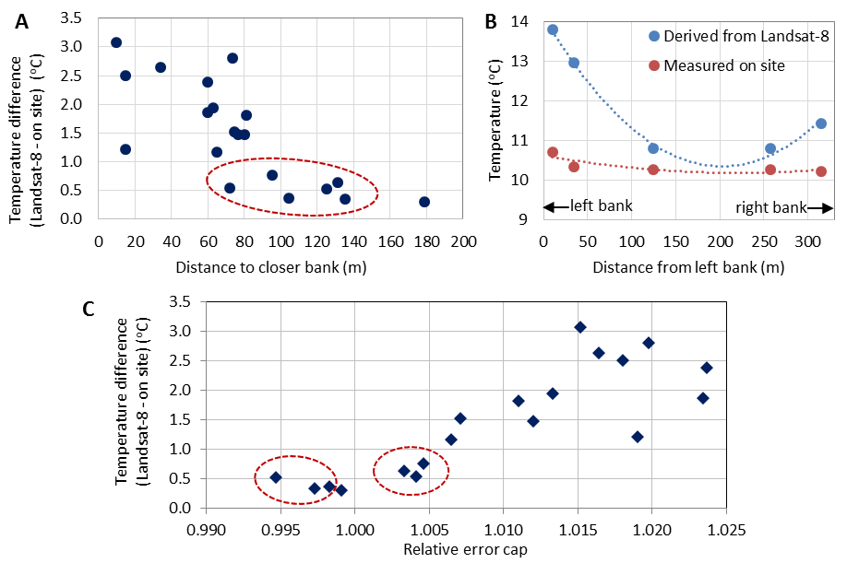
Fig. 8. Comparison between Landsat 8 derived and the on site measured water surface temperatures from 22 Jan. 2018. a) Difference between on-site and Landsat 8 temperatures versus distance to closest bank; b) Landsat 8 on site temperatures across the river at section 64 km; c) Difference between Landsat 8 and on site temperatures versus the estimated convolution error cap. The pixels corresponding to the red-circled points would have been eliminated by the river width criterion, but they are selected for temperature mapping by the proposed method.
It is worth mentioning that all temperatures retrieved from Landsat 8 are greater than the ones measured on site. For those pixels with relative error limit closest to 1, the absolute difference mean is about 0.35 °C. This finding is consistent with other studies which found a systematic overestimation of Landsat 8 temperatures (Barsi et al., 2014). On the other hand, the proposed algorithm allowed a maximum relative radiance error of 1.005 due to convolution mixing. For a surface temperature of 25 °C, the 1.005 relative error corresponds to an absolute increment lower than 0.4 °C through Plank´s law. Some observed absolute differences in Fig. 8.c are higher. This may be related to near-bank effects and is further discussed in Section 4.3.

4.2 Enhanced retrieval of reliable pixels for temperature mapping
Fig. 9 compares the three-pixel width mask recommended by Handcock et al. (2006) and the selected pure water TIRS pixels for the same Landsat 8 image. It can be observed that virtually no pixels remain in the three-pixel width mask upstream of coordinate 50 km (Fig. 9.b). An overlay of both masks (Fig. 9.d) evidences that the proposed algorithm selects pure water thermal pixels (in blue) well beyond those determined within the three pixel width recommendation (in green).

Fig. 9. Comparison of the three pixel width mask and the selected pure water TIRS pixels on the image from 5 March 2016: a) water mask obtained by thresholding the MNDWI; b) river pixels in reaches wider than three thermal pixels; c) pure water TIRS pixels for the estimated arrangement of the original thermal pixels; d) overlay of masks A (orange, bottom), B (green, on top) and C (blue) between distances 45 and 65 km.

Fig. 10 illustrates the selection of pixels that could be affected by cubic convolution-induced mixing on two dates. This figure reveals that, on the March image, the main limitation to retrieve reliable thermal data is the difficulty to find TIRS pixels contained within the water mask, while the effect of the convolution is limited to the resampled pixels very close to the banks. In August, when the water stage is lower and the radiance contrast between water and banks is higher, more pixels are affected by the convolution mixing.
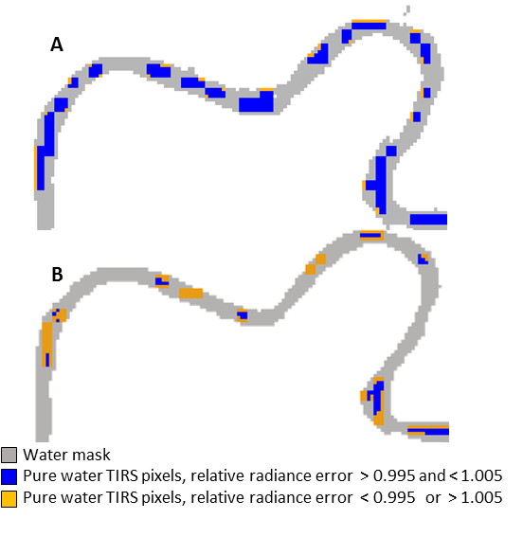
Fig. 10. Water mask between coordinates 55 and 60 km for the images of: a) 5 Mar. 2016; b) 12 Aug. 2016. Pure-water TIRS pixels are highlighted in blue and orange. The orange pixels are susceptible to relative radiance errors lower than 0.995 or higher than 1.005 due to the cubic convolution resampling, based on the maximum contrast between neighbouring water and non-water pixels.

4.3 Water surface temperature profiles
The longitudinal temperature profiles obtained with the proposed method are depicted in Fig. 11. These profiles provide instantaneous, spatially distributed measurements over the 162 km long study area, including fluvial temperatures upstream of the reservoir and right downstream of the dam, which cannot be observed by ground-based means.
The upper 65 km of the study area correspond to the flowing Ebro River, upstream of the wider reservoir. As expected, the temperatures retrieved by the proposed method in this reach are spatially discontinuous, being sparser towards the upper and narrowest upstream end. When compared among dates, the surface temperatures are spatially more frequent for the March and April images, and become more scarce later on in the year when: (a) the river level went down (Fig. 2) and the wetted width decreased; (b) the thermal radiance contrast with the bank increased in the warmer months and, consequently, more near-bank pixels resulted affected by the convolution mixing effect. It is worth mentioning that there is a trade-off between the convolution mixing error threshold and the number of retrievals in the river upstream of the reservoir. If the 1±0.005 threshold is relaxed, more pixels are selected for temperature retrieval, but the obtained values show higher dispersion, due to increased convolution mixing.
Some high spatial-frequency temperature variations are observed between distances 45 km and 65 km in Fig. 11. The flowing water enters the reservoir in this reach and some surface temperature spatial heterogeneities are expected. Fullerton et al. (2015) found that temperature variability was common in an extensive study of river longitudinal profiles. However, other sources of error related to near-bank effects may contribute to these variations and also explain that the maximum error between predicted and measured surface temperature in Section 3.10 is higher than that expected for a 1.005 relative error cap. The near-bank effects include: (a) presence of small amounts of weeds or other materials, which were not masked out by the MNDWI thresholding; (b) radiance emitted from the near-bank environment and reflected by the water surface. Handcock et al. (2006) estimated the water reflection of the thermal radiance from a tree in summer to be in the order of 0.01 to 0.09 W m⁻² μm⁻¹ sr⁻¹ for Lambertian or specular reflection, respectively. This reflection can increase the observed water temperature by 0.10 ºC to 0.65 ºC, although the specular reflection of near-bank radiance is unlikely for Landsat 8’s low viewing angles. Considering both, the maximum allowed convolution mixing and the near-bank vegetation influence in the summer, the error of retrieved temperatures in the narrows part of the river is bounded at 0.50 ºC to 1.05 ºC, which is the consistent with the errors found in Section 3.10.

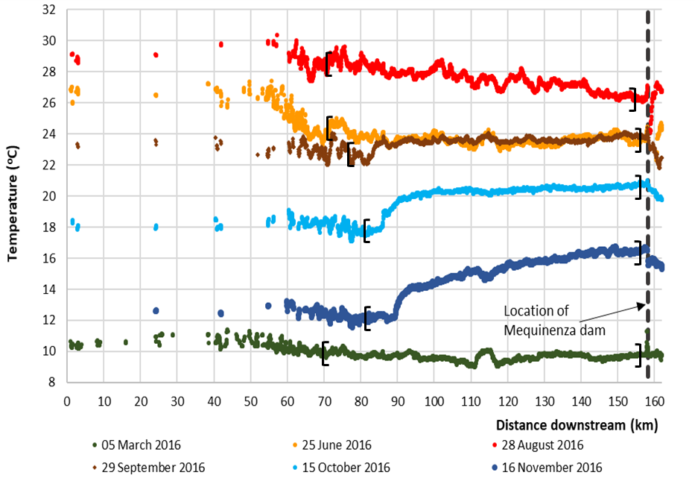
Fig. 11. Temperature profiles along the fluvial axis derived from the analysed Landsat 8 images. The black brackets indicate the upstream and downstream most sections where temperature is retrieved following the three-pixel width criterion.

Table 2. Number of pixels selected for temperature mapping along the river centre line following the proposed method and the three-pixel width criterion.
Image date | 5 Mar. | 25 Jun. | 28 Aug. | 29 Sep. | 15 Oct. | 16 Nov.
Proposed method | 3233 | 2927 | 2845 | 2827 | 2782 | 2664
Three pixel width criterion | 2385 | 1804 | 2086 | 2088 | 2001 | 1928

Despite being discontinuous, the retrievals in the 65 km upper reach capture the temperature of the inflowing water unaffected by the Mequinenza impoundment. This reach is narrower than 300 m, and no temperatures would be recovered if a three-pixel minimum width criterion were used. Neither would be right downstream of the dam.
The obtained longitudinal temperature profiles disclose unique information regarding the thermal gradients in the Ebro River and Mequinenza reservoir at the regional scale. By informing of the river temperatures upstream and downstream of the reservoir, the presented methodology enables a comprehensive assessment of the reservoir thermal impact and provides quantitative spatial evidence of its thermal buffering effect. The analysis of the reservoir thermal impact is beyond the scope of this article, but it is worth noting the sharp thermal gradient observed in the September, October and November profiles between distances 80 km and 90 km. This sharp gradient indicates the plunge section where the colder inflowing river dives under the warm surface of the thermally stratified reservoir. A thermal feature is observed on some profiles between coordinates 112 km and 115 km. As shown in Fig. 1, these coordinates correspond to a closed loop of the reservoir, so the thermal feature provides insight of its differential thermal behaviour. When water is being turbined at the Mequinenza dam, the surface temperature right downstream the dam is also indicative of the temperature in the reservoir bottom from where it is abstracted. Only 2 km downstream of the dam, at the end of the study reach, the Segre tributary joins the Ebro River causing further temperature mixing which are observable in the June and August profiles in Fig. 11.

5. CONCLUSIONS
Stream temperature mapping from satellite thermal data has been limited to reaches wider than three thermal pixels. Here, a new algorithm has been proposed to extend the retrieval of surface temperature from Landsat data to river reaches of one to three pixels width. The algorithm undertakes a refined selection of pixel values deemed reliable for temperature mapping on image basis. Radiance values derived from pure water native thermal pixels, non-corrupted by the cubic convolution resampling are selected for surface water temperature retrieval.
The proposed method was applied to seven Landsat 8 images of a 162 km-long reach in the Ebro River, encompassing a wide reservoir and the upstream and downstream reaches of width lower than 300 m, i.e. three Landsat 8 thermal pixels. Surface temperature profiles were determined for the entire study reach. As expected, temperature retrievals in the narrow segments were spatially discontinuous, being sparser as the river becomes narrower or the thermal contrast with the banks increases. Compared to ground truth measurements in a reach narrower than three Landsat 8 pixels, the retrieved temperatures showed absolute errors ranging from +0.35 ºC to +0.95 ºC. These errors are within the accuracy expected from satellite water surface mapping and are consistent with those due to convolution resampling under the imposed threshold and due to near-bank radiance scattering.
Despite the limitations in the accuracy and spatial frequency of the temperature retrievals, the presented methodology opens the possibility to the observation of stream thermal gradients at the regional scale in many river reaches narrower than three thermal pixels. The method can be applied to any Landsat satellite thermal bands by adjusting the native pixel spacing.
The temperature profiles obtained in this study disclose unique information regarding the thermal gradients in the Ebro River and Mequinenza reservoir at the regional scale, which cannot be observed by ground-based means. By informing of the river temperatures upstream and downstream of the reservoir, the proposed method allows a comprehensive assessment of the reservoir thermal impact and provides quantitative spatial evidence of its thermal buffering effect. The presented methodology is being applied to longer time series of Landsat 8 and Landsat-7 images of the study area to investigate long-term changes in the thermal behaviour of the Mequinenza reservoir, and possible impacts on the aquatic biota and abstracted water quality.

6. ACKNOWLEDGEMENTS
The authors thank the anonymous reviewers for their thorough revision and valuable suggestions. We would like to express our gratitude to Fundación Iberdrola and Institut Flumen-CIMNE for their funding contributions to this study. We also thank the USGS for the availability of the treasured Landsat data set.

7. REFERENCES
Alcântara EH, Stech JL, Lorenzzetti JA, Bonnet MP, Casamitjana X, Assireu AT and Novo EM (2010). Remote sensing of water surface temperature and heat flux over a tropical hydroelectric reservoir. Remote Sensing of Environment, 114, 2651-2665.
Asner, G. P., Wessman, C. A. and Privette, J. L. (1997). Unmixing the directional reflectances of AVHRR sub-pixel landcovers. IEEE Transactions on Geoscience and Remote Sensing, 35(4), 868-878.
Barsi, J., Schott, J., Hook, S., Raqueno, N., Markham, B., and Radocinski, R. (2014). Landsat 8 Thermal Infrared Sensor (TIRS) Vicarious Radiometric Calibration. Remote Sensing, 6, 11607.
Barsi JA, Schott JR, Palluconi FD, Hook SJ. 2005. Validation of a web-based atmospheric correction tool for single thermal band instruments, p. 1-7. In J.J. Butler [ed.], Earth Observing Systems X. San Diego, CA.
Barsi JA, Barker JL, Schott JR. 2003. An Atmospheric Correction Parameter Calculator for a single thermal band earth-sensing instrument, p. 3014-3016. 2003 IGARSS: Learning From Earth's Shapes and Colours. Toulouse.
Caissie D. 2006. The thermal regime of rivers: a review. Freshwater Biology 51:1389-1406.
Carbonneau P. E. and Herve Piegay, eds. 2012. Fluvial Remote Sensing for Science and Management, Chapter 5. John Wiley & Sons, Ltd.
Cherkauer KA, Burges SJ, Handcock RN, Kay JE, Kampf SK, Gillespie AR, 2005. Assessing satellite-based and aircraft-based thermal intrared remote sensing for monitoring Pacific Northwest river temperature. JAWRA Journal of the American Water Resources Association 41:1149-1159.
Despini, F and Teggi, S. 2013. Analysis of temperature maps of waterbodies obtained from ASTER TIR images, International Journal of Remote Sensing, 34:9-10, 3636-3653.
Díaz-Delgado R, Ameztoy I, Cristóbal J, Bustamante J. 2010. Long time series of Landsat images to reconstruct river surface temperature and turbidity regimes of Guadalquivir Estuary, p. 233-236. IGARSS 2010. Honolulu.
Dugdale SJ. 2016. A practitioner's guide to thermal infrared remote sensing of rivers and streams: recent advances, precautions and considerations. WIREs Water 3:251-268.
Fullerton AH, Torgersen CE, Lawler JJ, Faux RN, Steel EA, Beechie TJ, Ebersole JL, Leibowitz SG. 2015. Rethinking the longitudinal stream temperature paradigm: region-wide comparison of thermal infrared imagery reveals unexpected complexity of river temperatures. Hydrological Processes 29:4719-4737.
Gustafson WT, Handcock RN, Gillespie AR, Tonooka H. 2003. Image sharpening method to recover stream temperatures from ASTER images, p. 12. International Symposium on Remote Sensing. SPIE,
Ha W, Gowda PH, Howell TA, 2013. A review of downscaling methods for remote sensing-based irrigation management: part I. Irrigation Science 31:831-850.
Handcock RN, Gillespie AR, Cherkauer KA, Kay JE, Burges SJ, Kampf SK, 2006. Accuracy and uncertainty of thermal-infrared remote sensing of stream temperatures at multiple spatial scales. Remote Sensing of Environment 100:427-440.
Handcock RN, Torgersen CE, Cherkauer KA, Gillespie AR, Tockner K, Faux RN, Tan J. 2012. Thermal infrared remote senhsing of water temperature in riverine landscapes. In: PE Carbonneau and H Piégay (eds.), Fluvial Remote Sensing for Science and Management, p. 85-113. John Wiley & Sons, Ltd.
Irons JR, Dwyer JL, Barsi JA, 2012. The next Landsat satellite: The Landsat Data Continuity Mission. Remote Sensing of Environment 122:11-21.
Lalot E, Curie F, Wawrzyniak V, Baratelli F, Schomburg S, Flipo N, Piegay H, Moatar F. 2015. Quantification of the contribution of the Beauce groundwater aquifer to the discharge of the Loire River using thermal infrared satellite imaging. Hydrology and Earth System Sciences 19:4479-4492.
Legrand M.C., Pietras G. Brogniez M., Haeffelin N.K., Abuhassan and M. Sicard (2000). A high-accuracy multiwavelength radiometer for in situ measurements in the thermal infrared. Part I: characterization of the instrument, J. Atmos. Ocean Techn., 17, 1203-1214.
Ling F, Foody GM, Du H, Ban X, Li X, Zhang Y, Du Y. 2017. Monitoring thermal pollution in rivers downstream of dams with Landsat ETM+ thermal infrared images. Remote Sensing 9:1175.
Lowney CL. 2000. Stream temperature variation in regulated rivers: Evidence for a spatial pattern in daily minimum and maximum magnitudes. Water Resources Research 36:2947-2955.
Martí-Cardona, B. and Prats, J., 2018. Reservoir thermal impact captured by satellite images, In Proc. of the 5th IAHR Europe Congress, A. Armanini and E. Nucci [ed.], Trento, Italy.Martí-Cardona B, Arbat-Bofill M, Prats-Rodríguez J, Pipia L. 2016. Thermal remote sensing for reservoir modelling and management, p. 4. In L. Ouwehand [ed.], Living Planet Symposium 2016. ESA Communications, Prague, Czech Republic.
Martí-Cardona B, Steissberg TE, Schladow SG, Hook SJ, 2008. Relating fish kills to upwellings and wind patterns in the Salton Sea. Hydrobiologia 604:85-95.
Nichols AL, Willis AD, Jeffres CA, Deas ML. 2014. Water temperature patterns below large groundwater springs: management implications for coho salmon in the Shasta River, California. River Research and Applications 30:442-455.
Niclòs, R., Pérez-Planells, L., Coll, C., Valiente, J. A., & Valor, E. (2018). Evaluation of the S-NPP VIIRS land surface temperature product using ground data acquired by an autonomous system at a rice paddy. ISPRS Journal of Photogrammetry and Remote Sensing, 135, 1-12.
Niclòs, R., Dona, C., Valor, E., Bisquert, M., Niclòs, R., Doña, C., ... & Bisquert, M. (2014). Thermal-Infrared Spectral and Angular Characterization of Crude Oil and Seawater Emissivities for Oil Slick Identification. IEEE Trans. Geoscience and Remote Sensing, 52(9), 5387-5395.
Pahlevan N, Schott JR, Franz BA, Zibordi G, Markham B, Bailey S, Schaaf CB, Ondrusek M, Greb S, Strait CM, 2017. Landsat 8 remote sensing reflectance (Rrs) products: Evaluations, intercomparisons, and enhancements. Remote Sensing of Environment 190:289-301.
Parkinson EA, Lea EV, Nelitz MA, Knudson JM, Moore RD, 2016. Identifying Temperature Thresholds Associated with Fish Community Changes in British Columbia, Canada, to Support Identification of Temperature Sensitive Streams. River Research and Applications 32:330-347.
Prats J, Armengol J, Marcé R, Sánchez-Juny M, Dolz J. 2011. Dams and reservoirs in the lower Ebro River and its effects on the river thermal cycle, p. 77-95. In: D. Barceló and M. Petrovic (eds.), The Ebro River Basin. Springer, Berlin Heidelberg.
Prats J, Val R, Dolz J, Armengol J. 2012. Water temperature modeling in the Lower Ebro River (Spain): Heat fluxes, equilibrium temperature, and magnitude of alteration caused by reservoirs and thermal effluent. Water Resources Research 48:W05523.
Prats J, Reynaud N, Rebière D, Peroux T, Tormos T, Danis, P-A. 2018. LakeSST: Lake Skin Surface Temperature in French inland water bodies for 1999-2016 from Landsat archives. Earth System Science Data 10:727-743.
Ramos-Fuertes A, Marti-Cardona B, Bladé E, Dolz J, 2014. Envisat/ASAR Images for the Calibration of Wind Drag Action in the Doñana Wetlands 2D Hydrodynamic Model. Remote Sensing 6:379.
Roura Carol M. 2004. Incidència de l'embassament de Mequinensa en el transport de sòlids en suspensió i la qualitat de l'aigua del riu Ebre. PhD thesis. Universitat de Barcelona.
Roy DP, Borak JS, Devadiga S, Wolfe RE, Zheng M, Descloitres J, 2002. The MODIS Land product quality assessment approach. Remote Sensing of Environment 83:62-76.
Roy DP, Wulder MA, Loveland TR, C.E W, Allen RG, Anderson MC, Helder D, Irons JR, Johnson DM, Kennedy R, Scambos TA, Schaaf CB, Schott JR, Sheng Y, Vermote EF, Belward AS, Bindschadler R, Cohen WB, Gao F, Hipple JD, Hostert P, Huntington J, Justice CO, Kilic A, Kovalskyy V, Lee ZP, Lymburner L, Masek JG, McCorkel J, Shuai Y, Trezza R, Vogelmann J, Wynne RH, Zhu Z, 2014. Landsat 8: Science and product vision for terrestrial global change research. Remote Sensing of Environment 145:154-172.
Schneider P, Hook SJ, 2010. Space observations of inland water bodies show rapid surface warming since 1985. Geophys. Res. Lett. 37:n/a-n/a.
Sentlinger GI, Hook SJ, Laval B, 2008. Sub-pixel water temperature estimation from thermal-infrared imagery using vectorized lake features. Remote Sensing of Environment 112:1678-1688.
Shuter BJ, Post JR, 1990. Climate, Population Viability, and the Zoogeography of Temperate Fishes. Transactions of the American Fisheries Society 119:314-336.
Sicard, M., Spyak, P. R., Brogniez, G., Legrand, M., Abuhassan, N. K., Pietras, C., and Buis, J. P. (1999). Thermal infrared field radiometer for vicarious cross-calibration: characterization and comparisons with other field instruments. Optical Engineering, 38 (2), 345-356.
Steissberg, T. E., Hook, S. J., & Schladow, S. G. (2005). Measuring surface currents in lakes with high spatial resolution thermal infrared imagery. Geophysical research letters, 32(11).
Teggi, S., 2012. A technique for spatial sharpening of thermal imagery of coastal waters and of watercourses.International Journal of Remote Sensing,33(10), 3063-3089.
Torgersen, C. E., Price, D. M., Li, H. W., & McIntosh, B. A., 1999. Multiscale thermal refugia and stream habitat associations of chinook salmon in northeastern Oregon. Ecological Applications, 9(1), 301-319.
Torgersen, C. E., Faux, R. N., McIntosh, B. A., Poage, N. J., & Norton, D. J. (2001). Airborne thermal remote sensing for water temperature assessment in rivers and streams. Remote Sensing of Environment, 76(3), 386-398.
U.S. Geological Survey, 2017a. Landsat 8 data users handbook, Version 2.0, LSDS-1574. Available at: https://landsat.usgs.gov/sites/default/files/documents/Landsat8DataUsersHandbook.pdf (last accessed in Oct 2017).
U.S. Geological Survey. 2017b. Product Guide. Landsat 8 Surface Reflectance Code (LaRSC) Product, p. 39. U.S. Geological Survey, https://landsat.usgs.gov/sites/default/files/documents/lasrc_product_guide.pdf.
U.S. Geological Survey, 2017c. TIRS Stray Light Correction Implemented in Collection 1 Processing, accessed online at https://landsat.usgs.gov/april-25-2017-tirs-stray-light-correction-implemented-collection-1-processing (last accessed in Oct 2018).
USGS EROS User Services, 2017. Email communication on 20 Sep.
Ward JV, 1985. Thermal characteristics of running waters. Hydrobiologia 125:31-46.
Wawrzyniak V, Piégay H, Poirel A, 2012. Longitudinal and temporal thermal patterns of the French Rhône River using Landsat ETM+ thermal infrared images. Aquatic Science 74:405-414.
Webb BW, Hannah DM, Moore RD, Brown LE, Nobilis F. 2008. Recent advances in stream and river temperature research. Hydrological Processes 22:902-918.
Xu H, 2006. Modification of normalised difference water index (NDWI) to enhance open water features in remotely sensed imagery. Int. J. Remote Sens. 27:3025-3033.
Yvon-Durocher G, Caffrey JM, Cescatti A, Dossena M, Giorgio Pd, Gasol JM, Montoya JM, Pumpanen J, Staehr PA, Trimmer M, Woodward G, Allen AP, 2012. Reconciling the temperature dependence of respiration across timescales and ecosystem types. Nature 487:472-476.
Zhan, W., Chen, Y., Zhou, J., Li, J., Liu, W., 2011. Sharpening thermal imageries: a generalized theoretical framework from an assimilation perspective. IEEE Trans. Geosci. Remote Sens. 49, 773-789.
Zoran M. 2011. Nuclear power plant's water thermal plume assessment by satellite remote sensing data. Proceedings of the Global Conference on Global Warming 2011. Lisbon, Portugal.

List of Figure Captions
Fig. 1. Study area: Ebro river reach, including the Mequinenza reservoir. The distance coordinates used for the analysis of the results are indicated at 10 km intervals. The Mequinenza dam is located at the distance coordinate 158.1 km.
Fig. 2. Mean daily inflow and outflow discharge and water surface elevation in the Mequinenza reservoir in 2016. The vertical lines indicate the dates of the Landsat 8 acquisitions.
Fig. 3. Selection of pure thermal pixels for plotting the river thermal profile: a) a water mask is derived from Landsat 8’s 30 m optical bands; b) the position of the native 100 m TIRS pixels is assumed, the pure water 100 m pixels and the 30 m pixels within (in red) are selected accordingly; c) The selected 30 m pixels within a 3x3 neighbourhood of the river centre line are averaged to obtain the river long thermal profile.
Fig. 4. Water-leaving radiance profiles for different assumed positions of the native TIRS pixels, in the Landsat 8 image from 5 Mar. 2016: the river surface width is clearly wider than 400 m downstream of coordinate 85 km.; between 83 and 85 km the river width was between 300 m and 400 m on the image date. Blue and green dot profiles exhibit the lowest radiance, indicating that they were obtained from pure water thermal pixels.
Fig. 5. Water leaving radiance in a reach of the Mequinenza reservoir, derived from Landsat 8´s band 10, acquired on 22 Jan. 2018. The black line indicates the water perimeter. Water-land radiance mixing is revealed by the thermal gradients perpendicular to the banks.
Fig. 6. Per-pixel estimation of the radiance mixing caused by the cubic convolution for a given land to water radiance contrast.
Fig. 7. Flow chart of the processing steps, from the generation of the water mask to the selection of reliable pixels for temperature mapping.
Fig. 8. Comparison between Landsat 8 derived and the on-site measured water surface temperatures from 22 Jan. 2018. a) Difference between on-site and Landsat 8 temperatures versus distance to closest bank; b) Landsat 8 on site temperatures across the river at section 64 km; c) Difference between Landsat 8 and on site temperatures versus the estimated convolution error cap. The pixels corresponding to the points circled in red-circled points in Fig. 8.a and Fig. 8.c would have been eliminated by the river width criterion, but they are selected for temperature mapping by the proposed method.
Fig. 9. Comparison of the three pixel width mask and the selected pure water TIRS pixels on the image from 5 March 2016: a) water mask obtained by thresholding the MNDWI; b) river pixels in reaches wider than three thermal pixels; c) pure water TIRS pixels for the estimated arrangement of the original thermal pixels; d) overlay of masks A (orange, bottom), B (green, on top) and C (blue) between distances 45 and 65 km.
Fig. 10. Water mask between coordinates 55 and 60 km for the images of: a) 5 Mar. 2016; b) 12 Aug. 2016. Pure-water TIRS pixels are highlighted in blue and orange. The orange pixels are susceptible to relative radiance errors lower than 0.995 or higher than 1.005 due to the cubic convolution resampling, based on the maximum contrast between neighbouring water and non-water pixels.
Fig. 11. Temperature profiles along the fluvial axis derived from the analysed Landsat 8 images. The black brackets indicate the upstream and downstream most sections where temperature is retrieved following the three pixel width criterion.

List of Table Captions
Table 1. Cloud free Landsat 8 acquisitions over the Mequinenza reservoir used in this study
Table 2. Number of pixels selected for temperature mapping along the river centre line following the proposed method and the three-pixel width criterion.

